The doors of the Bicentenary in Cambodia were opened by a Princess

- Princess Norodom Arunrasmy of Cambodia presided the opening of the Bicentenary celebrations in the Kingdom.
- More than 4,000 students, teachers and past pupils camped at the Don Bosco Phnom Penh campus for three days.

Phnom Penh, January 30, 2015 - The celebrations of the Don Bosco Bicentenary in the Kingdom of Cambodia began on January 30 with a Royal guest: Princess Norodom Arunrasmy, the youngest daughter of late King Norodom Sihanouk and sister of current king Norodom Sihamoni.

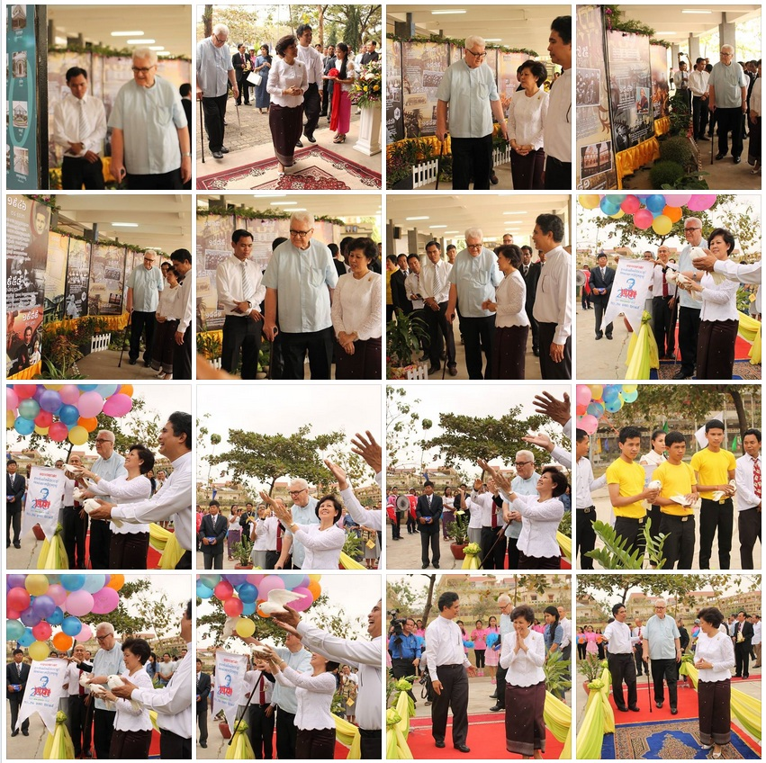
​
More than 4,000 persons camped for two nights at the Campus of the Don Bosco Technical School in Phnom Penh: students from Poipet, Battambang, Phnom Penh and Sihanoukville, teachers, past pupils, the Salesian Family and representatives from the Cambodian government and the Catholic Church.

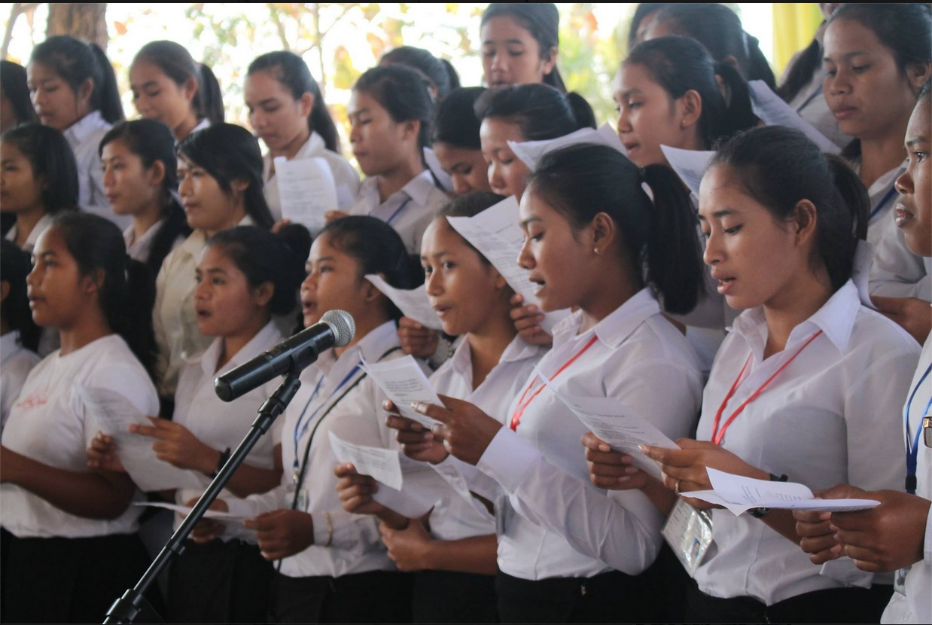
​Students of the Salesian sisters singing for Don Bosco.

The program started with the welcoming of Princess Norodom Arunreaksmey in the morning of January 30 by Fr. Roel Soto, Superior of the Cambodian Delegation, Fr. John Visser, Country Representative and other members of the Salesian Family.

Watch the arrival of Princess Norodom Arunreaksmey in our Youtube channel:

https://www.youtube.com/watch?v=xsPA5q_VxV8

https://www.youtube.com/watch?v=ZBEYJ6_BTRE

https://www.youtube.com/watch?v=abLzTn-U94g

Princess Norodom Arunreaksmey congratulated the Salesian Family for the event of the Don Bosco Birth Bicentenary and appreciated the contribution of the Salesians to the education of Cambodian children and youth since the troublesome times of the countries' history.

Solemn Mass

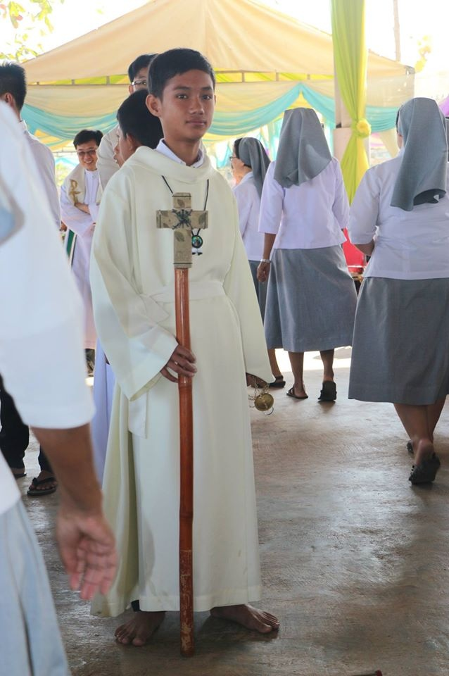
​

The Solemn Mass was presided by Mgr. Olivier Schmitthaeusler, Bishop of the Apostolic Vicariate of Phnom Penh.

Watch the Cambodian Catholic Church report on the Don Bosco Bicentenary: http://youtu.be/ZLkZAYzW6QA

The celebrations of the Cambodian Bicentenary of Don Bosco is an occasion to evaluate the social impact of the Salesian works in the Kingdom since the refugee camps. For this reason, there was a permanent exhibition of the Don Bosco projects.

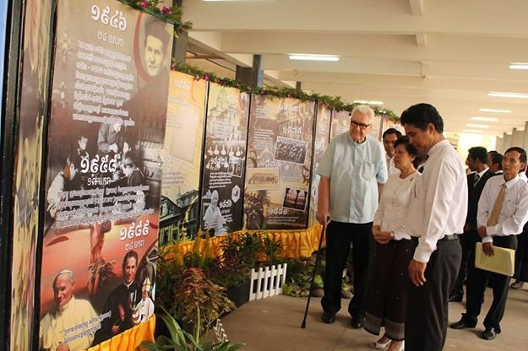
Fr. John Visser and Fr. Roel Soto showing the exhibition to Princess Norodom Aronreaskmey.

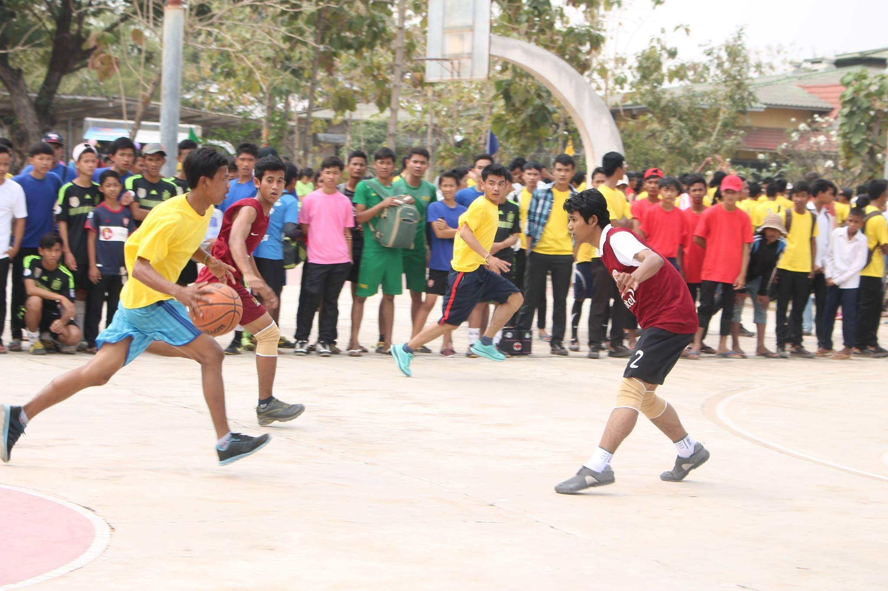
​​
The Celebrations included sports and culture, of course, where young people could show their their talents and meet their friends. Teams from different schools met in friendly games.

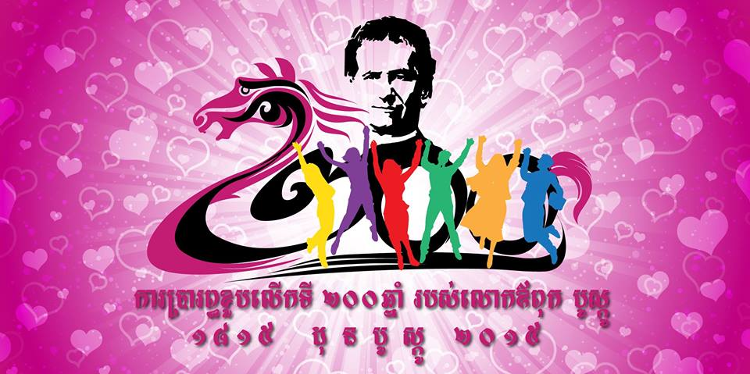
​
The Bicentenary Celebrations in Cambodia are not over. The different schools and works of the Salesian Family have their own schedules to say #HappyBirthdayDonBosco.

For this reason, the Don Bosco Cambodia Audiovisual Center doubled the Strenna 2015 in Khmer. "It is the first time that a Rector Major speaks clearly in Khmer language." You can watch the Strenna in Khmer here:

https://www.youtube.com/watch?v=YSg6Kd5-Xkc

For more news about the Bicentenary Celebrations in Cambodia, follow the official Youtube Channel:

https://www.youtube.com/channel/UCIWZptP30hXZhzclgBwURhA

And the Facebook Page:

https://www.facebook.com/bicentenarysdbkhmer?ref=bookmarks

@SDBofCambodia

---
លោកឪពុកសំណាង នាយកសាលាបច្ចកទេសដុនបូស្កូខេត្តកែប
Albeiro Rodas©2014. PRIVATE EMAIL. Do not print this email if it is not really needed. H.P. (+855) 97.371.2020. DonBoscoSihanoukville.org - DonBoscoKep.org Skype: Albeiror24. Facebook. @SDBofCambodia
DONATE: A/C No. 0700-01-041854-1-8 - Don Bosco Foundation of Cambodia Acleda Bank Plc. Kompot-Kep Branch -Swift code ACLBKHPP - P.O.Box 9801 - Kep City, Cambodia

