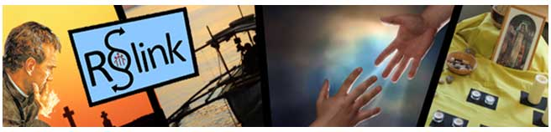
VIDEO flv, ogv, webm, mp4

WEDNESDAY, 16 JANUARY 2013

Personal reflection on the end of the relics pilgrimage of Don Bosco
Having spent two weeks travelling the country in draughty minibuses at unreasonable hours it would be normal to be relieved that the whole event is over. In fact as the relic of Don Bosco left the Sacred Heart Church in Battersea on Tuesday evening January 15th there were few dry eyes in the congregation. Some of the congregation reported a real sense of loss including some of the Bishops that attended the final farewell.
The idea of bringing relics to Great Britain was met by some scepticism by some members of the church and with enthusiasm by others. In the end the latter group won through and the pilgrimage can be said to have achieved its aims.
As a congregation in this country we wanted to unlock the wisdom of this saint for a church that has been embattled with various challenges over the last decade. We have tried to present the earthy, relational and optimistic lay spirituality of a saint who believed in people. His motto "give me souls, nothing else matters" underlines the focus on people. So whilst others argue rightly about liturgy and theology in one part of our church others, like Don Bosco speak about the politics of the Our Father and the need to let people know that they are loved.
One aspect of the experience of the relics made a powerful impression on the travelling team of thirty five mainly young people; they discovered the real experience of the catholic church in this country. Wherever they went, in England, Scotland and Wales they were welcomed by a community that cared. Each Cathedral was a community where the Gospel was being lived in hospitality before a prayer was said. The contact and confidence was immediate between the team and the local community. Don Bosco spoke about this confidence as being like an electric current that ran between people through which hearts were opened and needs were shared. That experience followed the team wherever they went.
This earthy and people-centered focus is balanced by a deep and almost mystical awareness of God's presence living in people. That was the energy that created resilient hospitality in each of the communities that welcomed the relics. It is a spirituality that we as a province want to offer to the church in this country in a much more explicit way. In a real sense we want to give this charism away to others so that they can recognise the intimate closeness of God in themselves and others.
We want to challenge parents youth workers and teachers to put into practice the preventive system of Don Bosco which changes these roles and especially parenting into a path of holiness.
We want to offer those who need more life balance a model that challenges us all to meet God in church but also in the school of life in the home that we create and most of all, in the playground of life.
We want to offer the whole country a way to make young people feel precious as well as challenged by life and to do that work for deeper and spiritual reasons whatever their faith background.
The Salesian network of lay people, Cooperators, Sisters, Brothers and Priests is spread across the country and ready to engage in a quiet and gentle affirmation of ordinary catholic life and Gospel living. They are also there to challenge us all to look on the world optimistically and meet life with a smile. Don Bosco's simple message is that holiness consists in being cheerful. His patron St Francis de Sales said that you can catch more bees with a spoonful of honey than with a barrel full of vinegar. That cheerful optimism, that honey, is what Don Bosco offers to our church in Great Britain as we move through changing times. Such a cheerful faith can move mountains of sadness and uncertainty. It can bind the church into a community balanced between the past and the future and free up the energy to live the resurrection as much as we live the cross.
We want, as a pilgrimage team to thank The Parish of OUr Lady and All Saints in Basildon who hosted our team for five days. There the team met a community focussed on Gospel hospitality and cheerfulness. Their warmth and care lifted the whole team at a time when we were all flagging.
Mr Gerry Kehoe managed this event for us with huge insight and dedication. Without his professionalism and the involvement of DPL event management we could not have presented Don Bosco so well to the country.
Thanks also go to Rualink the Salesian Media Office in Cowley for the late night work and the quality of their output. (see web site for details at www.donboscorelics.co.uk
Finally we owe a debt of gratitude to all the Archbishops of England, Wales and Scotland who opened their churches and their hearts to Don Bosco, the friend of youth.
The pilgrimage moves on through Europe and will reach Italy by 2015 for the 200th anniversary of the birth of Don Bosco.
David O'Malley SDB

St George's Cathedral, Southwark saw over a thousand pilgrims brave the rain, the snow, the sleet and even a power-cut to spend some time with Don Bosco on this, the last public day of The Pilgrimage of the Relics of Don Bosco.
Mass was celebrated by the Auxiliary Bishop of Southwark, Patrick Lynch, with Fr Martin Coyle preaching. After the later Closing Liturgy, which was led by Fr David O'Malley, the casket containing St John Bosco's relics was taken in procession out of the cathedral to a chorus of singing, applause and excitement.
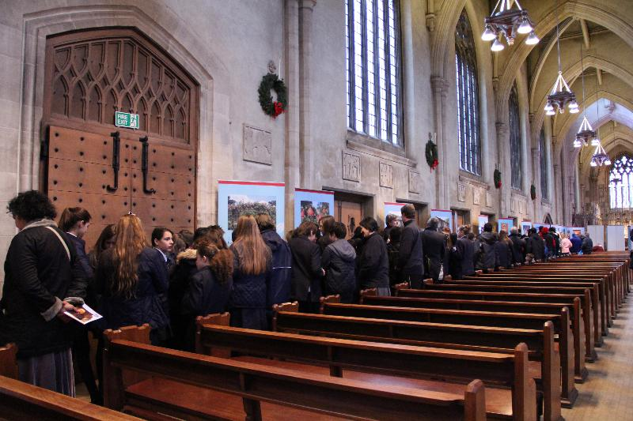
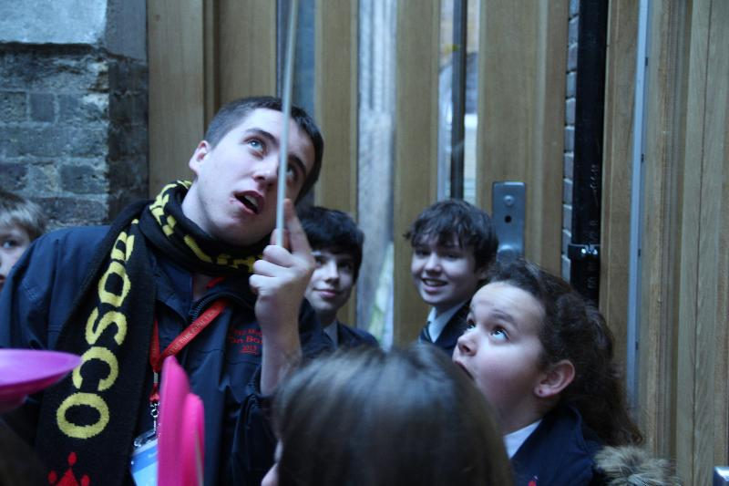
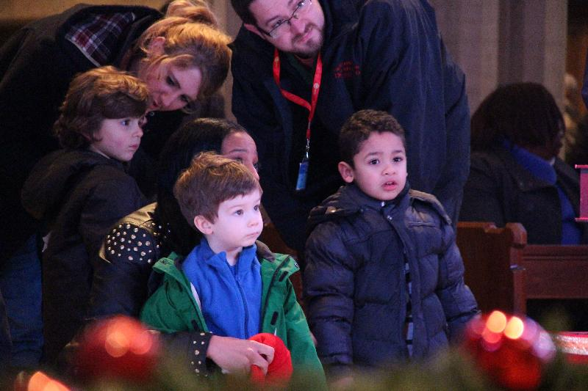
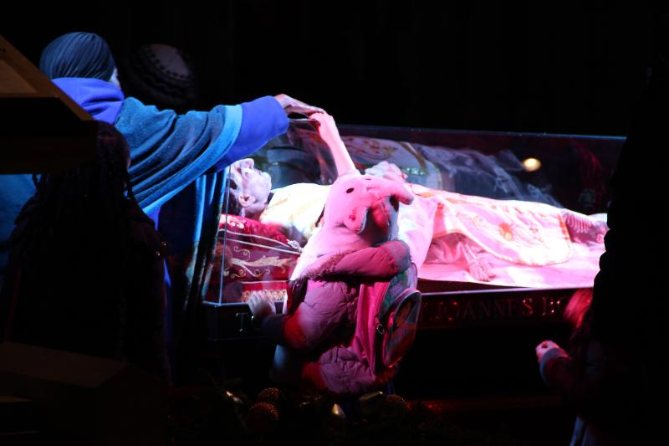
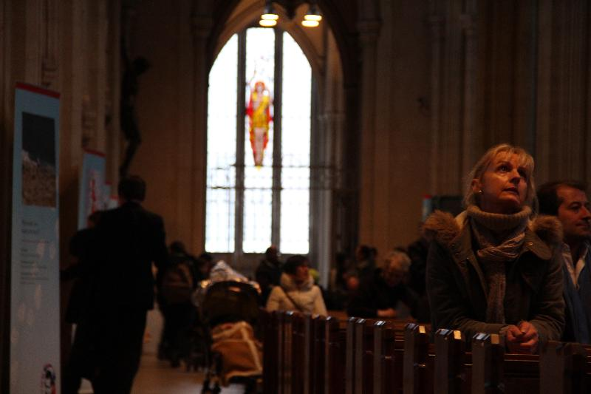
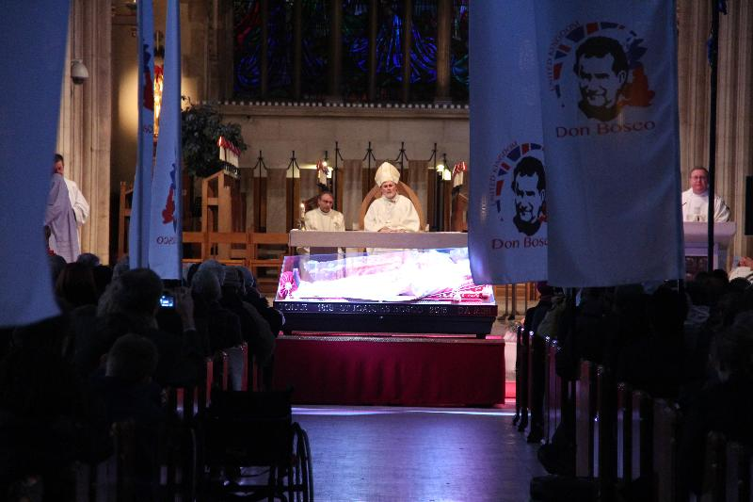
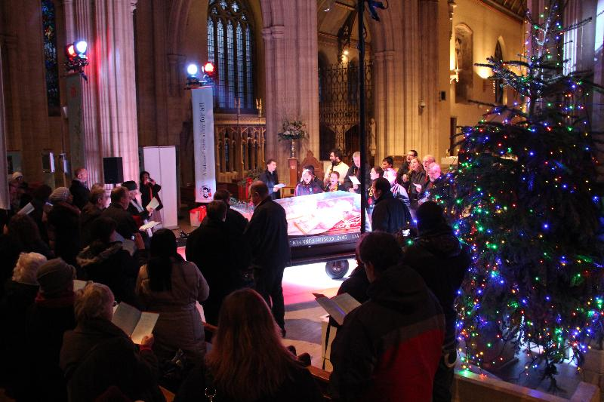
1. School children queue for the Pilgrim Experience
2. A member of the Pilgrimage Team demonstrates how to spin a plate
3. Young pilgrims are baffled and amazed
4. A moment to connect
5, 6. A prayerful Mass
7. Don Bosco prepares to leave Southwark
A quick trip back across the Thames, and arrival at St George's Cathedral, Southwark - the Diocese where the original Salesians arrived some 125 years ago.
Archbishop Peter Smith led the Eucharist with Fr Martin Coyle preaching.
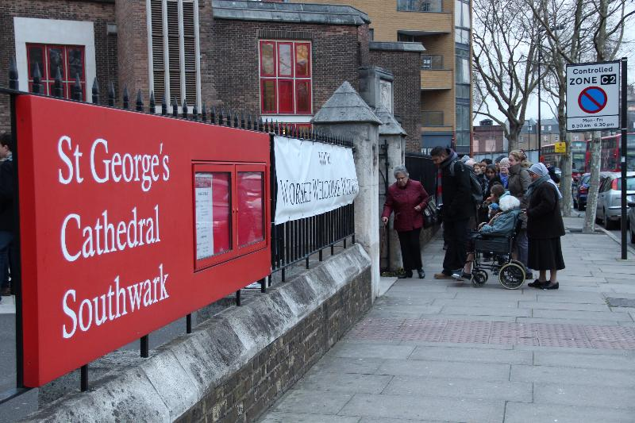
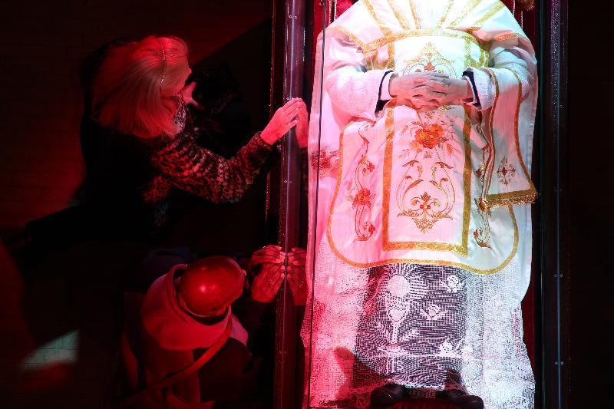
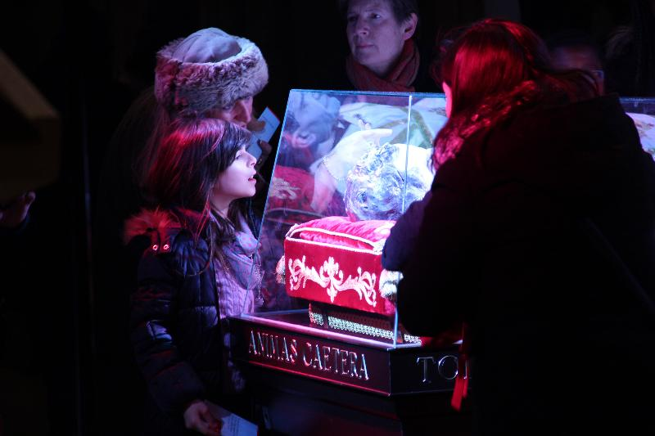
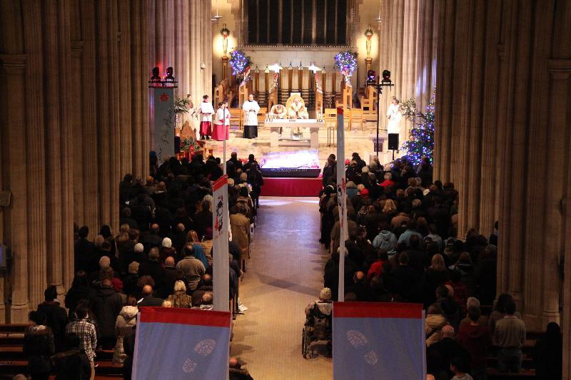
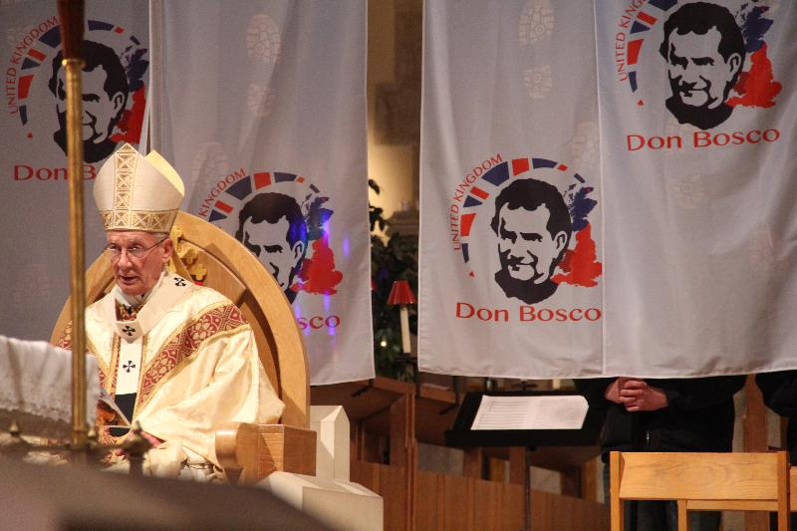
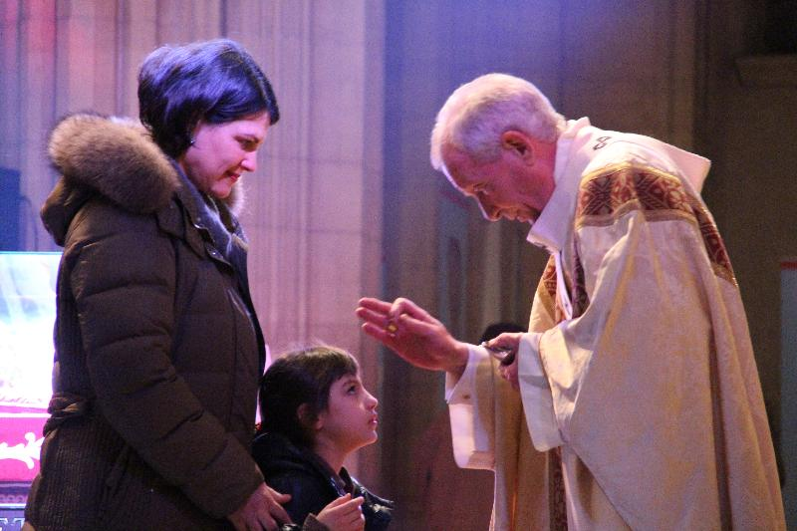
1. Queues in the cold weather
2&3 Pilgrims at the Casket
4&5 Holy Mass
6. Archbishop Peter's blessing
In a change to the advertised public programme, the Relics of Don Bosco were taken this morning into Feltham Young Offenders Institute.
After the initial request from the RC Chaplain, Fr Roger Reader, the UK Ministry of Justice sanctioned the visit.
Bishop Alan Hopes and the Provincial Fr Martin Coyle celebrated two morning masses with the young offenders (aged 15-18).
The young people have been preparing for this visit for a number of weeks, praying through Don Bosco.
Photographs were not allowed.
The Relics will now continue onto Southwark for today's venerating.
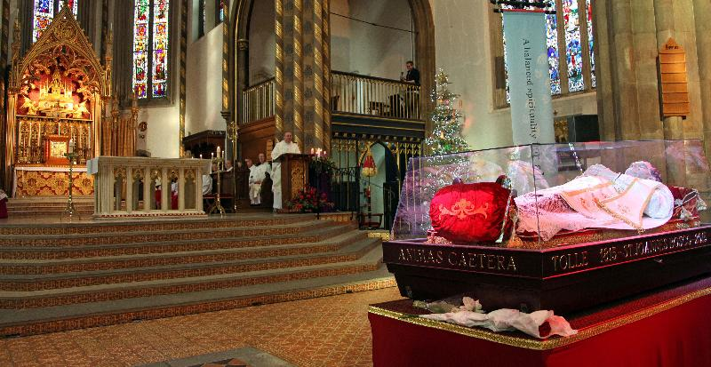
The Metropolitan Cathedral of the Most Precious Blood, Westminster opened its doors to well over 3500 people today.
The doors opened and the pilgrims came, and came and came - all ages, all races - the people of London (Westminster) opened their hearts to Don Bosco.
Auxiliary Bishop Alan Hopes, led a packed Cathedral in a beautiful Eucharist as people thanked God for the gift of Don Bosco.
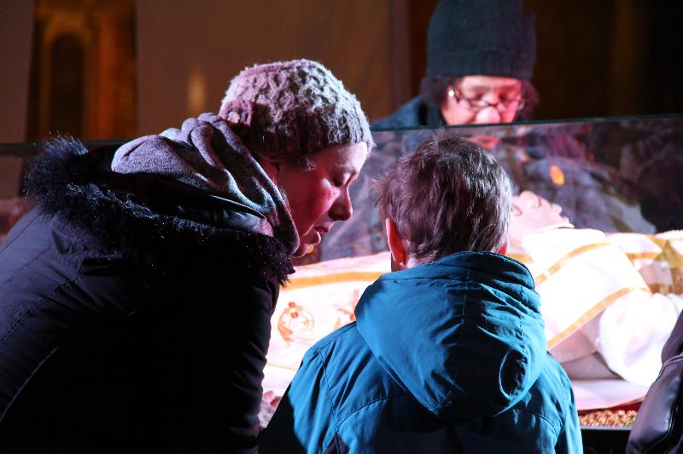
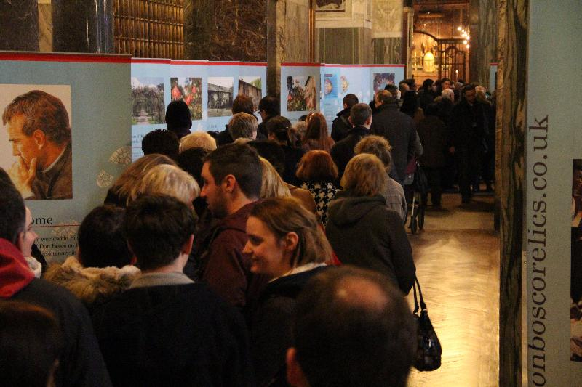
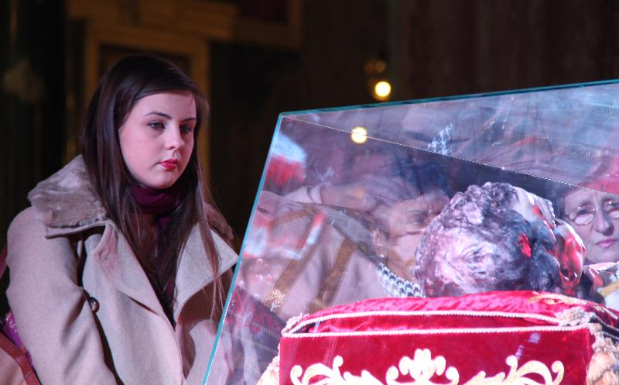
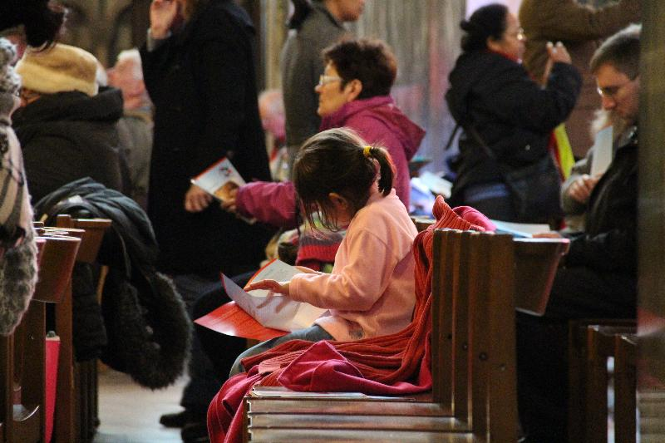
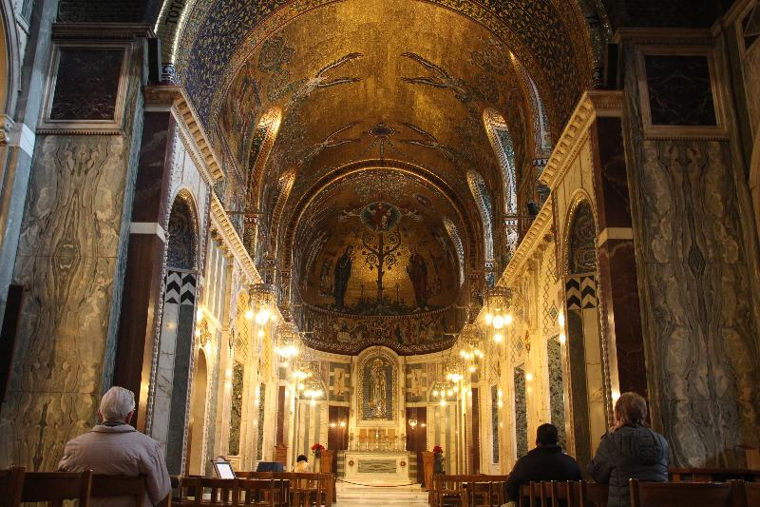
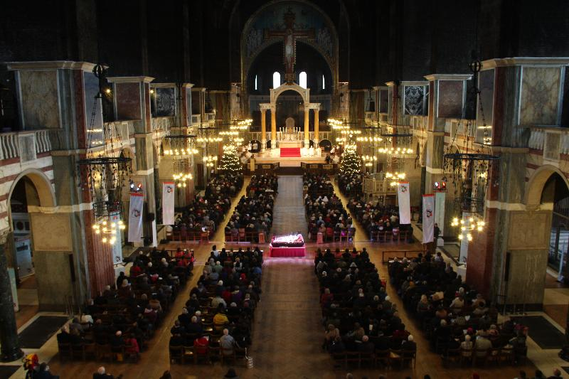
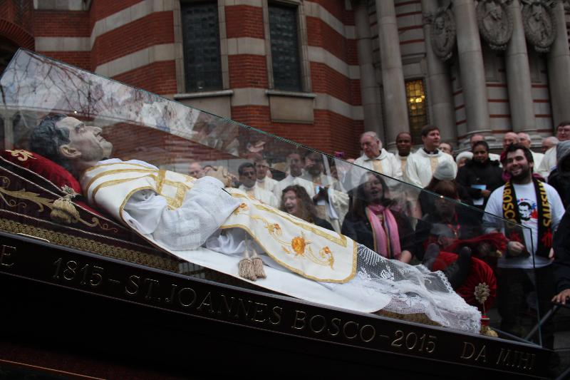
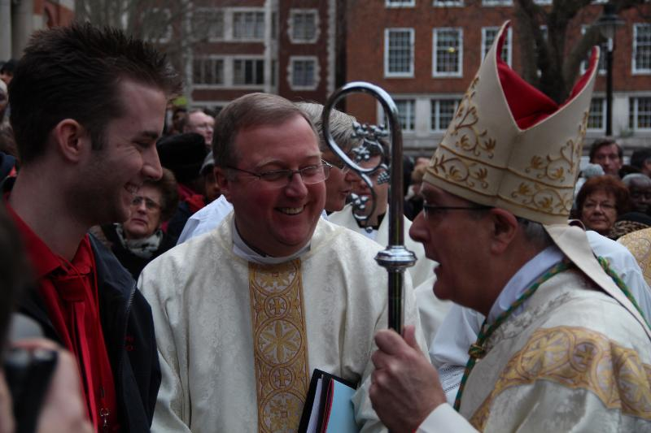
1. Mother and child
2. Queues at the Pilgrim Experience
3. Pilgrims at the Casket
4. Pilgrims of all ages
5. The beautiful Chapel of Our Lady
6. A packed Westminster Cathedral
7. The departure of the relics
8. The Bishop, Fr Martin and Ste of the organising Team relaxing
Welcome to Cardiff, and welcome to St David's Metropolitan Cathedral - Over 1000 school pupils and people flocked to praise God and pray at the Relics of St John Bosco. It was great to welcome parishioners from Newent and Cooperators from Cornwall to the event.
The Right Reverend Thomas Burns, Bishop of Menevia celebrated Holy Mass with Diocesan and Salesian priests, whilst Fr Martin Coyle preached the homily.
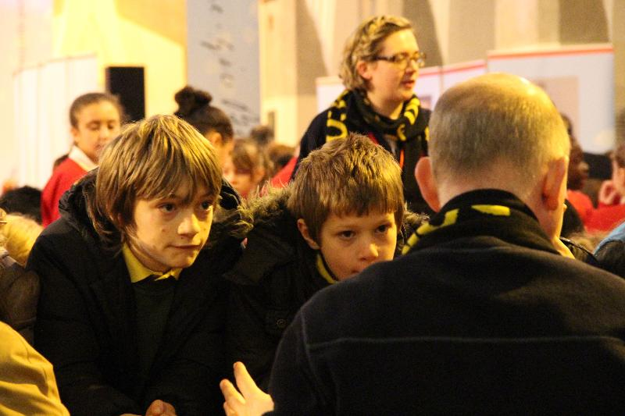
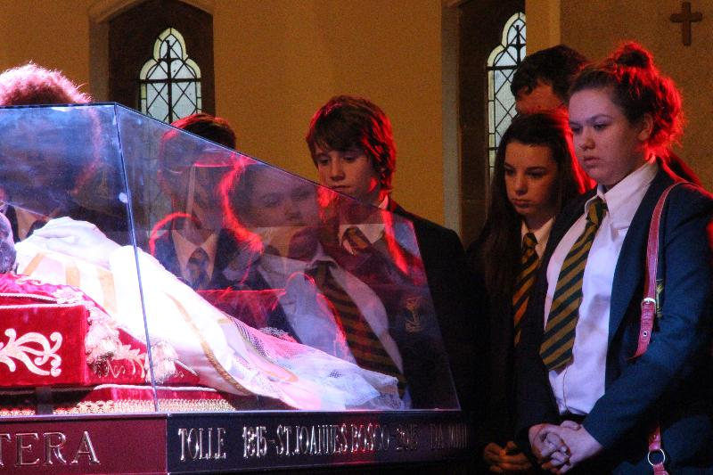
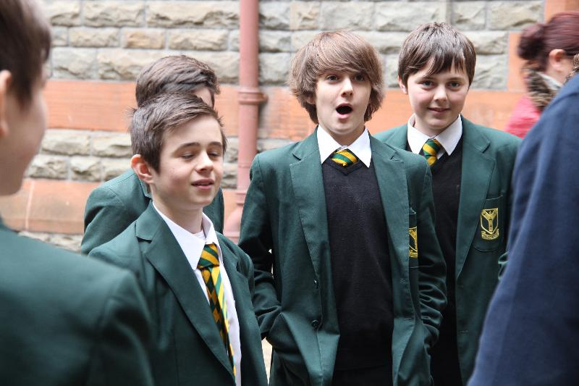
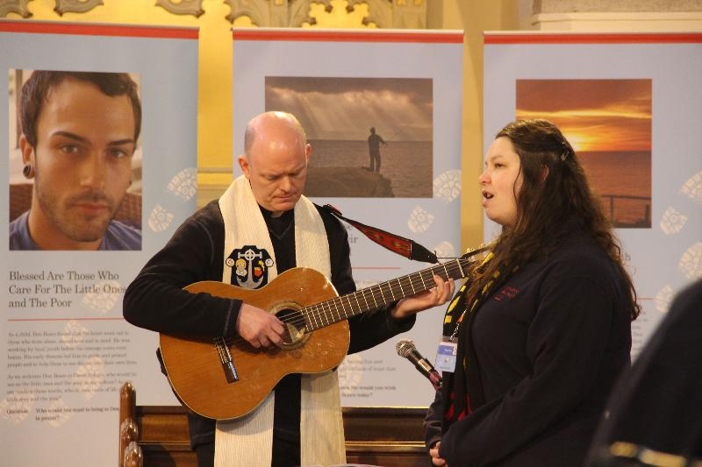
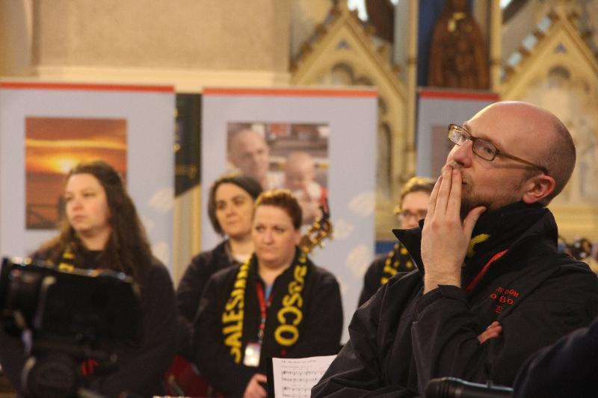
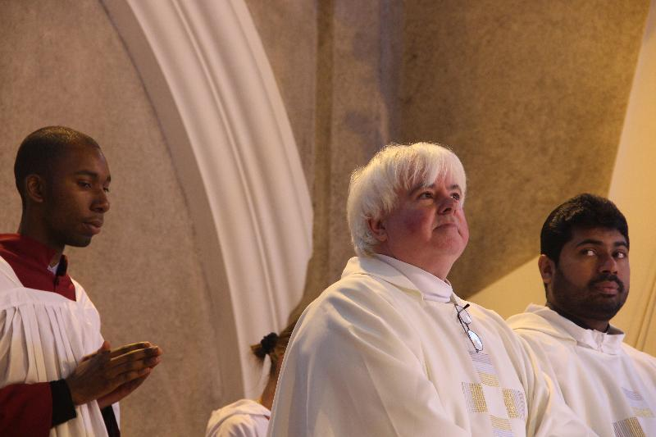
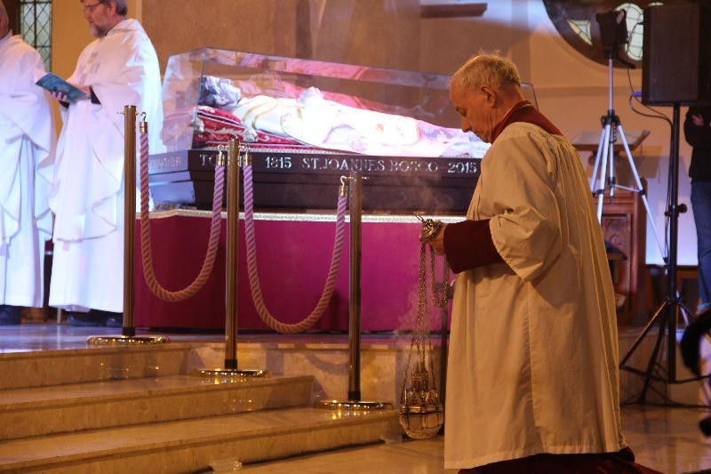
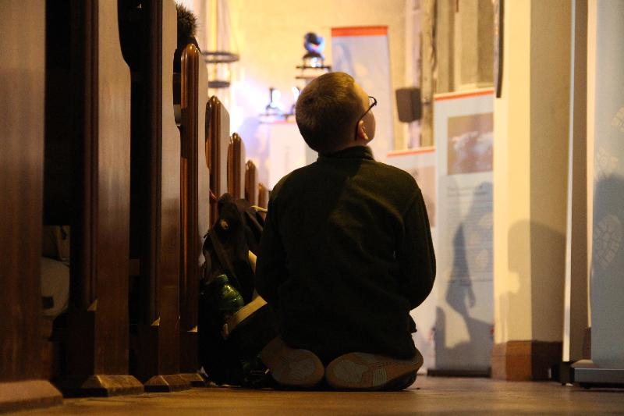
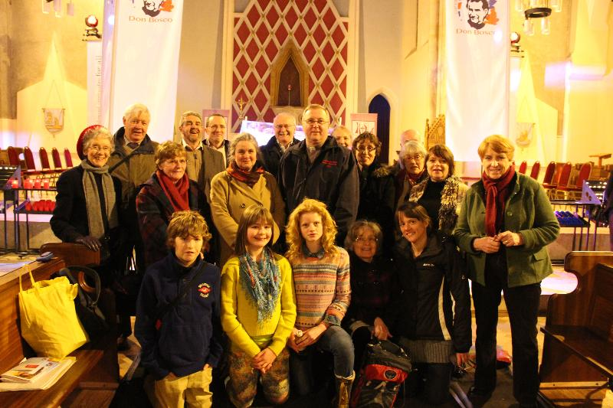
1 Children from St Peter's Primary School and Fr Martin Poulsom
2&3 Students from Archbishop McGraph Secondary School
4&5 Members of the Music Liturgy, including Ed Fawcett
6&7 Holy Mass including Fr Gerry and Fr Cyril
8 Pilgrims Experience Boards, and a young pilgrim
9 Parishioners from the Salesian Parish of Newent, and FR Martin Coyle SDB, Provincial
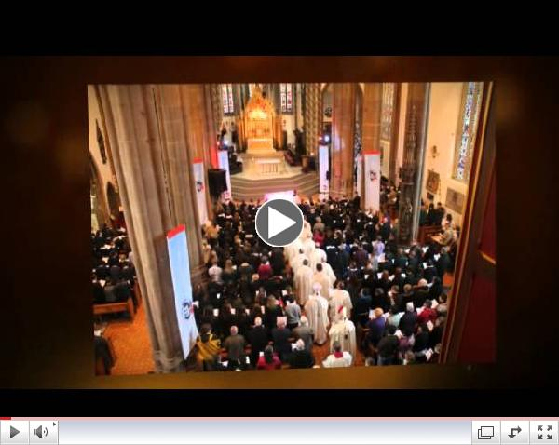
The Pilgrimage of the Relics of Don Bosco - BIRMINGHAM
webstreaming
Click here for more pictures!!
We apologise for the gremlins that got into last nights report.... what we meant to say was that:
Archbishop Bernard Longley led today's Eucharist, assisted by the retired Auxiliary Bishop of Birmingham, Philip Pargeter and Mgr Marcus Stock of the Bishops Conference of England and Wales.
Over 3500 people (including 2000 school children) pour into the Metropolitan Cathedral of Christ the King Liverpool, for a celebration of joy!!
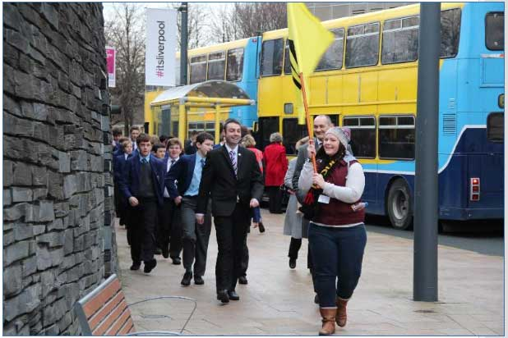
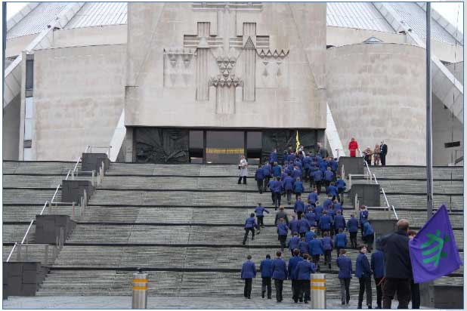
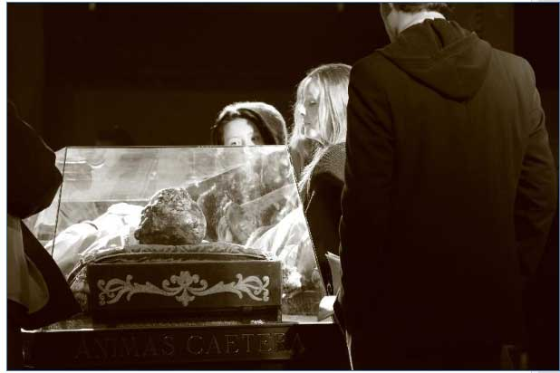
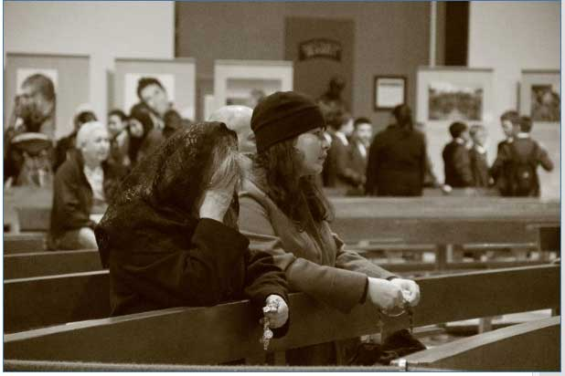
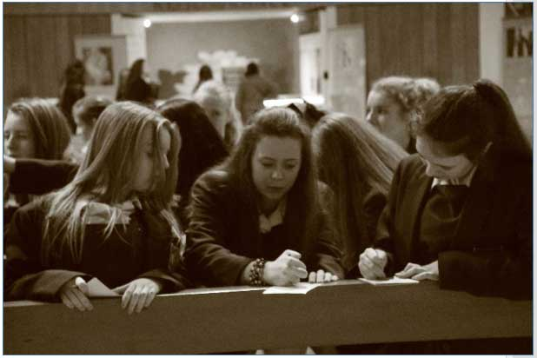
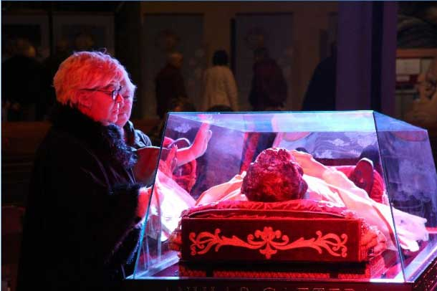
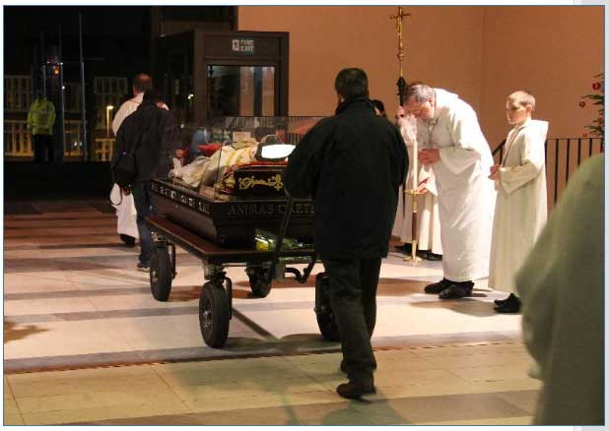
1 & 2 Young people from St Anselm's, Birkenhead
3 & 4 A personal encounter with a great saint
5. St John Bosco College students composing prayers
6. "Thank you!"
7. The Relics escorted from the Cathedral in honour
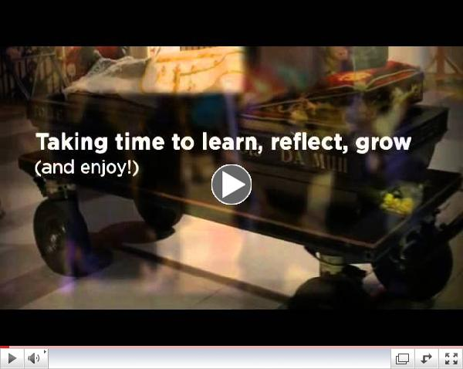
The Pilgrimage of the Relics of Don Bosco UK - LIVERPOOL
Click here for more pictures!!

