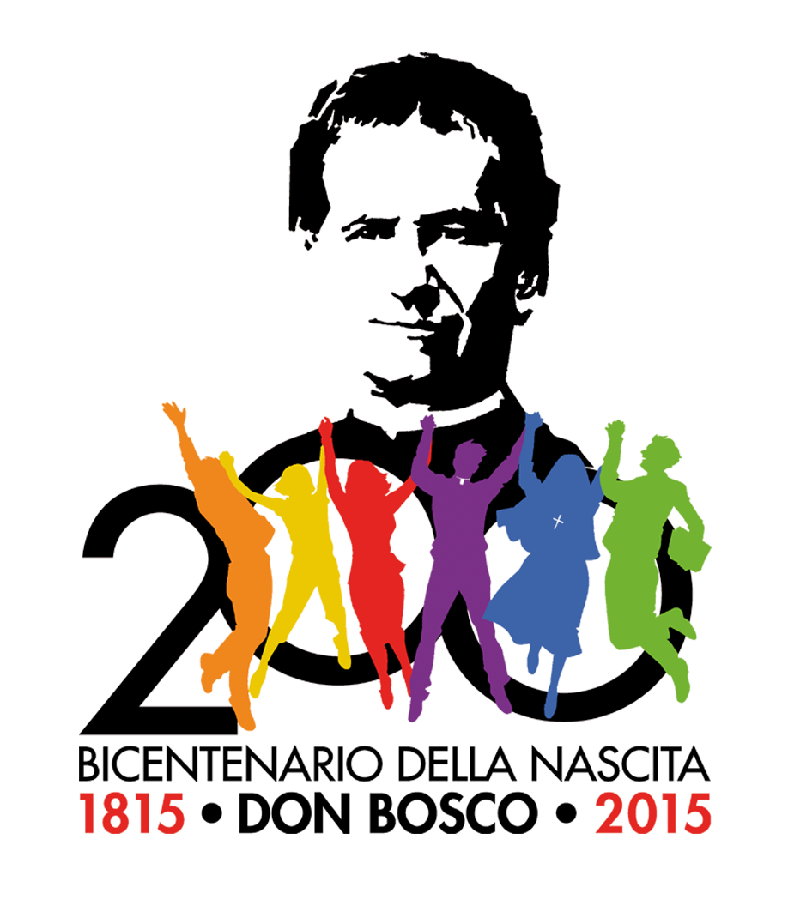
Bicentenary of Don Bosco's Birth

Presentation and significance of the Bicentenary

To recall the 200 years since Don Bosco's birth on August 16, 1815, the Rector Major of the Salesians of Don Bosco, Fr Pascual Chávez launched the celebrations for the Bicentenary to take place from 16 August 2014 to 16 August 2015.

1. Preparation for the Bicentenary
Preparations for the Bicentenary began in 2008 with the 26th General Chapter of the Salesians. The Congregation and Salesian Family began moving towards the Bicentenary by taking Don Bosco's motto, “Da mihi animas, cetera tolle” as its theme, and putting commitment to “beginning afresh from Don Bosco” as the basis for the years 2008-2014. In fact we can discover the origins of Don Bosco's charism, the purpose of the Congregation’s and Salesian Family’s mission, and their future, in this.
Moreover the Rector Major offered the Salesian Family the Pilgrimage of Don Bosco's Casket, which covered most countries around the world where the Salesian Family is present. The Pilgrimage concluded in February this year, 2014. It saw crowds of young people and families, all sharing admiration and gratitude for Don Bosco and his work, calling on his intercession, and wanting to be involved in the education of the young.
Finally a Three year preparation for the Salesian Family followed, marked by a three stage journey; the stages began on 16 August 2011, 16 August 2012 and 16 August 2013 respectively, and will conclude on 15 August 2014. Each stage has been aimed at developing an aspect of Don Bosco's charism: getting to know him and his history, his pedagogy, his spirituality.

2. Bicentenary theme
The Bicentenary theme, consistent with the three year preparation, refers to the Mission of Don Bosco with and for the young. Communication of this message took account of what has been gained and what has matured over three years of preparation. It should contribute not only to a deeper understanding of what Don Bosco's mission consists of today, but also to arousing numerous forces available to commit themselves in Don Bosco's style for the “salvation of the young”, especially the poorest, most excluded and abandoned.
This year concentrates on the journey of spiritual and pastoral renewal which the Congregation, Salesian Family and Salesian Youth Movement intend to pursue. For this we need to encourage simplicity of initiatives and highlight the relevance of the proposal, avoiding scattered effort, rhetoric and repetition, focusing instead on incisive and effective communication. Don Bosco and his mission should challenge everyone to give a response to the needs of the young today in various parts of the world.
Interesting from this perspective are the two international congresses on Salesian history and pedagogy, but especially the world gathering of young people from the Salesian Youth Movement, which will have “Young people for young people” as its theme. According to Don Bosco's vision it is the young people who are the pivotal players in the mission of education and evangelisation of their peers. The involvement of the young in Don Bosco's mission will help them be involved in doing good for their own companions.”

3. Significance of the Bicentenary
The Bicentenary intends above all to help make the figure of Don Bosco known and better understood: his relevance in the history of education and spirituality. Historical knowledge and understanding of Don Bosco are the departure point for identifying his relevance. Going to the sources of Don Bosco’s charism will help bring freshness and renewal to Salesian work today.
This celebration also aims at helping the Salesian Family to understand and take up its charismatic identity. Research into and awareness of identity encourages the discovery of the specific nature and effectiveness of the charism. We cannot work generically today, repeating what everyone else does; the plurality of initiatives demands the Salesian proposal have its own special character, from both a spiritual, and pastoral and educative point of view. The relevance of Don Bosco's charism lies in its identity. Charismatic identity also encourages its visibility, credibility and vocational fruitfulness.
With the Bicentenary the Salesian Family also intends to take on a greater involvement in Don Bosco's spiritual and apostolic programme: “Da mihi animas, cetera tolle”; this is the reason for his tireless work for “the glory of God and the salvation of souls.” Thus the Salesian Family can spur itself forward courageously on the frontiers of the mission to youth today. This means having a strong apostolic passion and generous availability.
The Bicentenary, finally, is an opportunity to give the charism of Don Bosco back to the Church and society. It is not the property of the Salesian Family but has been raised up by the Spirit for everyone. The task of the Salesian Family is to make him known so as to involve many forces in his spirituality and mission. Don Bosco today attracts many young people, lay people and families and urges them to become saints, getting involved in the educative and pastoral mission precisely through the concrete nature of this commitment.

4. Visits and pilgrimages to Don Bosco's places
Another initiative that is arousing interest is the bookings for pilgrimages to Don Bosco's places: Turin, the place of Don Bosco’s activity; Castelnuovo Don Bosco and surrounds, the place of his birth, family life and childhood; Chieri, the place of his human and seminary formation, but also of youthful friendships and apprenticeship in trades; …
Various historical, cultural and spiritual itineraries are being prepared in cooperation with civil authorities. These are not initiatives addressed to the Salesian Family alone; many local Churches are preparing bookings to get young people to know Don Bosco's spirituality; likewise for family groups and cultural associations. The geography of these places helps one better understand the history.
When visits to these places also have spiritual significance they become a pilgrimage and thus an opportunity for experiences of faith and an encouragement to holiness. Pilgrimage is an effective format and one much appreciated today for communicating spiritual experiences. The Salesian places hold an attraction and reminder to return to the sources of the charism.

5. Publications for the Bicentenary
Many publications are envisaged in various parts of the world: papers, studies, general reading, research, ... For example Italian Salesian Publishing Houses - LDC, SEI, LAS - are coordinating these initiatives. All this will contribute to an understanding of Don Bosco’s relevance. Amongst the publishing initiatives deserving of attention in view of the Bicentenary is the publication of the “Fonti salesiane” (Salesian Sources), by the Salesian Historical Institute.
This volume of sources is divided into three parts: wrings and documents on Don Bosco's history and the history of Salesian work; writings and testimonies of Don Bosco on education and schooling; writings and testimonies of Don Bosco on spiritual life. These three parts were coordinated respectively by Frs Francesco Motto, José Manuel Prellezo and Aldo Giraudo, Lecturers at the Salesian Pontifical University in Rome.
This volume of Salesian sources on Don Bosco and his work is entrusted to the Salesian Family, the Friends of Don Bosco, to those who admire Salesian work, to the young, laity who are involved in the spirit and mission of Don Bosco, and to families; everyone can draw on the fresh sources of the Salesian charism, the gift of the Spirit for the whole Church. Everyone can be inspired by Don Bosco's pedagogy and spirituality. With such a collection it will be much easier also for scholars to quote and make reference to a single collection of source materials.

6. Prayer to Don Bosco
Celebration of the Bicentenary is also an occasion to take up once more with the young, lay people, the Salesian Family and the Salesian Movement the prayer to Don Bosco, “Father and Teacher of Youth”.

Father and Teacher of Youth,
Saint John Bosco,
obedient to the gifts of the Spirit and open to the realities of your time
you were for the young, especially for the little ones and the poor,
a sign of God's love and predilection.
Be our guide
in walking in friendship with the Lord Jesus,
in such a way that we discover in him and in his Gospel
the meaning of our life
and the source of true happiness.
Help us to respond generously
to the vocation we received from God,
to be in daily life
builders of communion,
and collaborate with enthusiasm
in communion with the whole Church,
to build up the civilisation of love.
Obtain for us the grace of perseverance
in living a high degree of Christian life,
according to the spirit of the Beatitudes;
and grant that, guided by Mary Help of Christians,
we may find ourselves one day with you
in the great family of heaven. Amen

