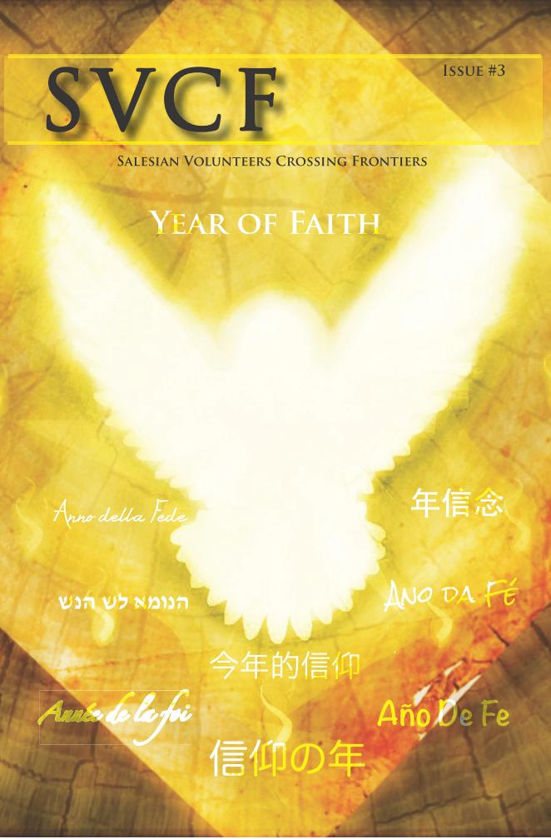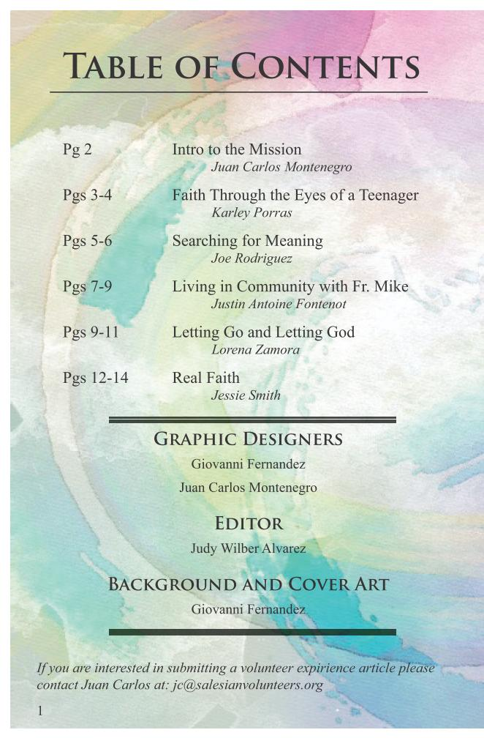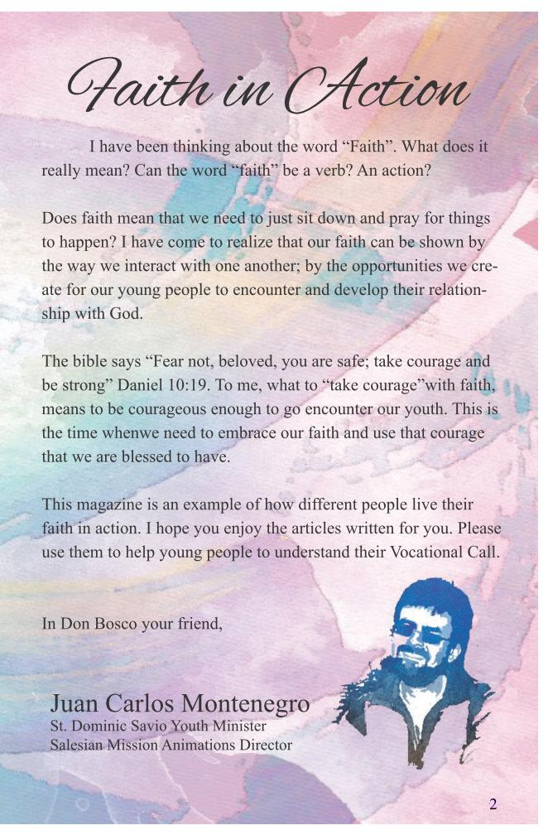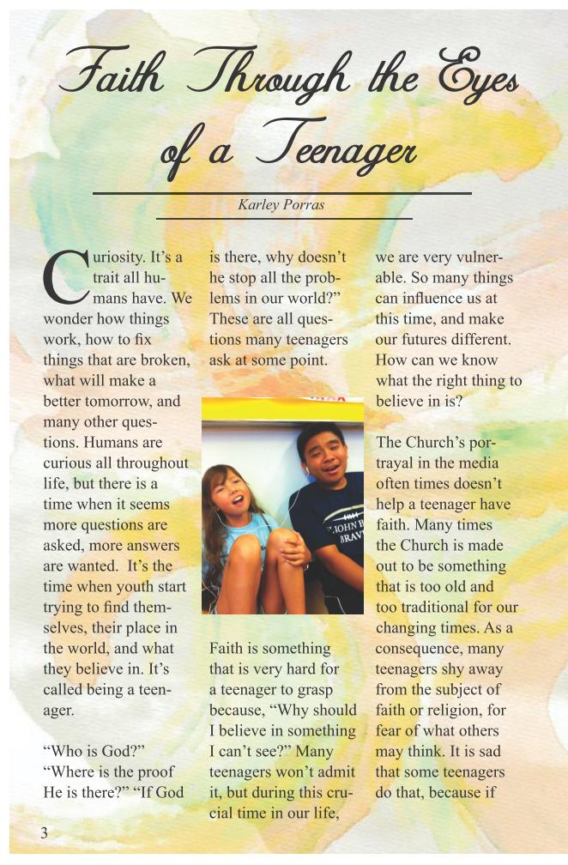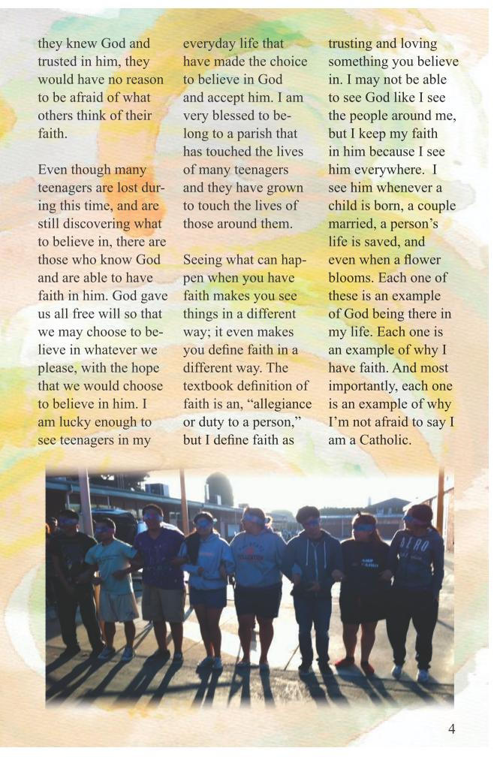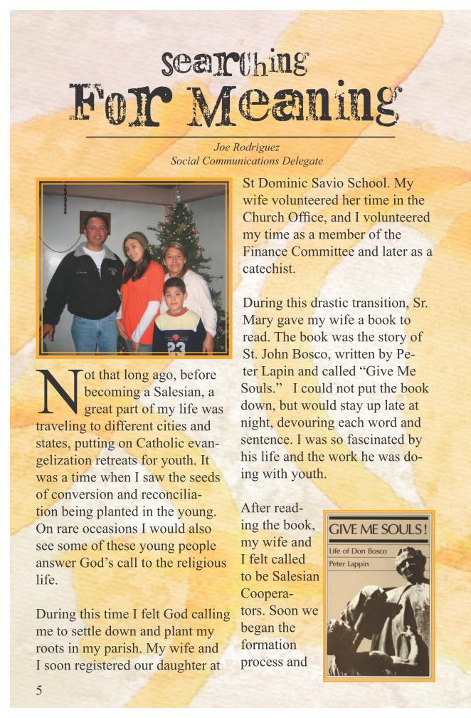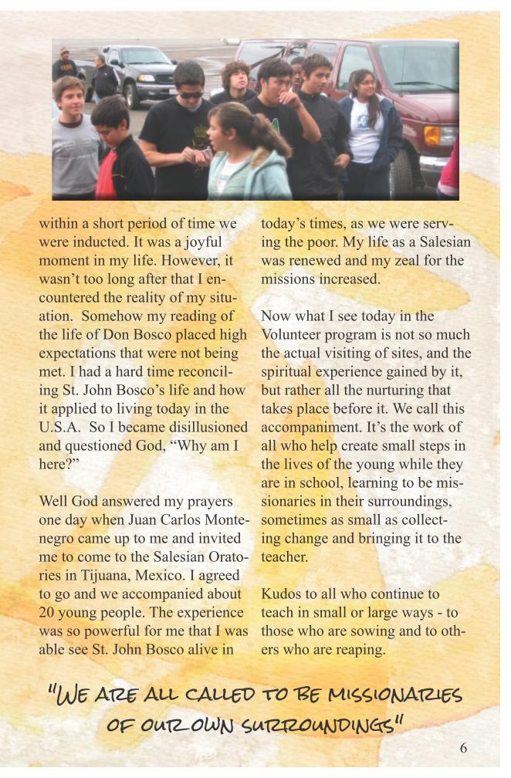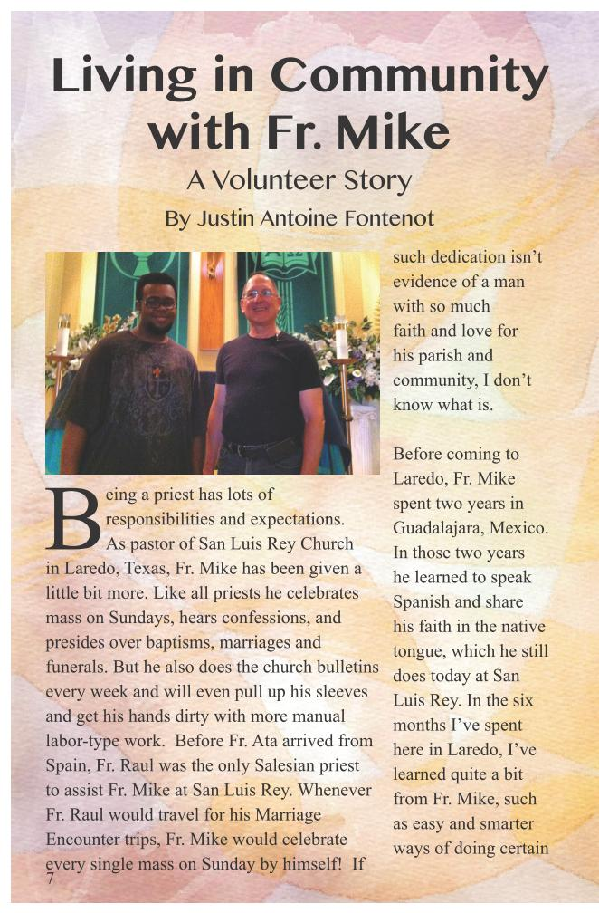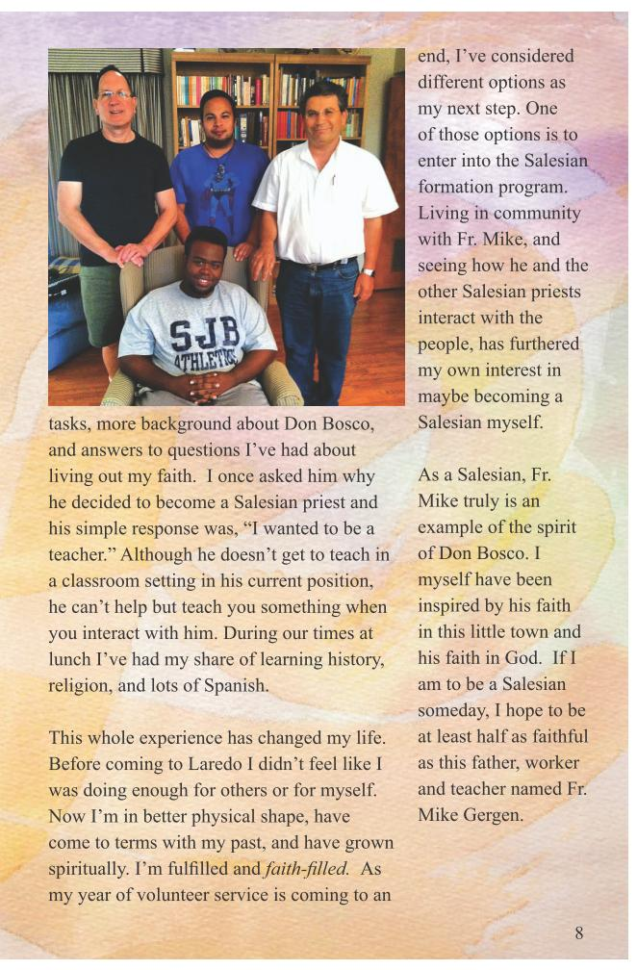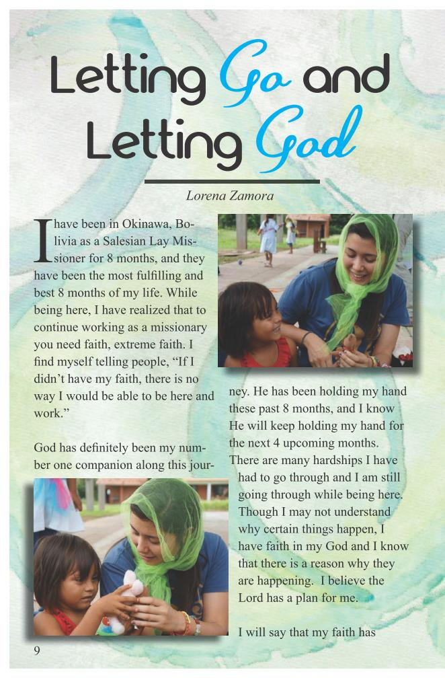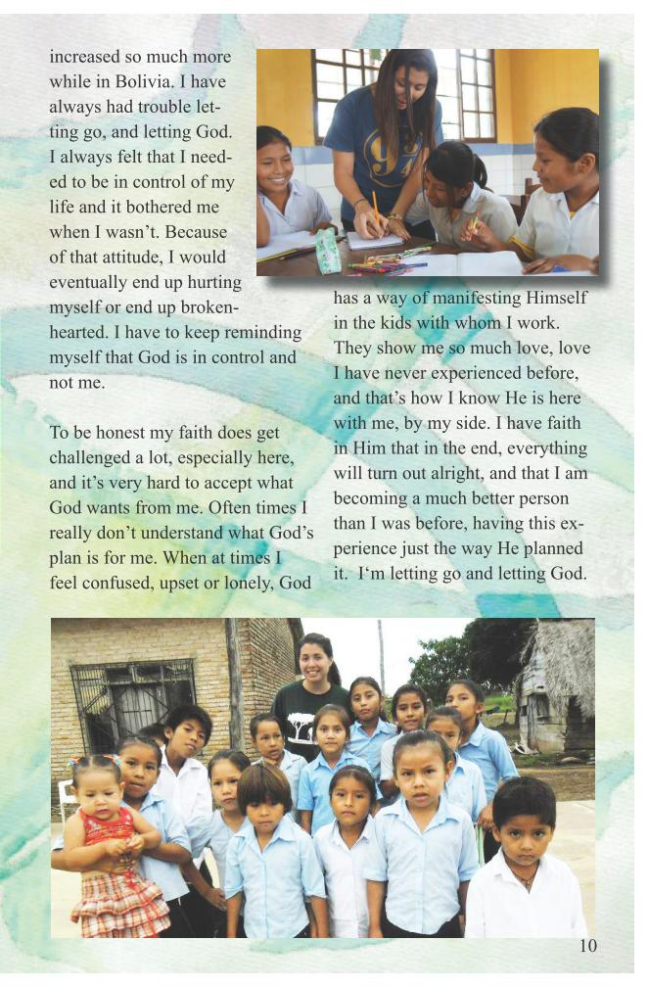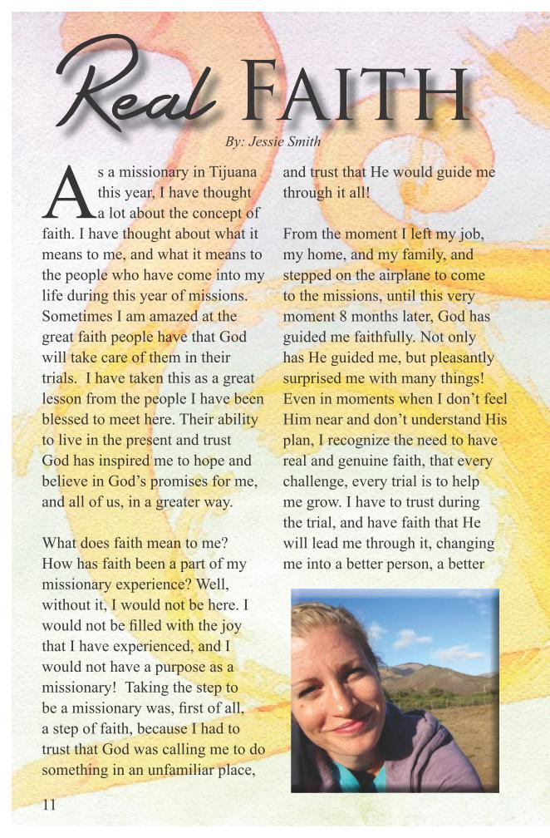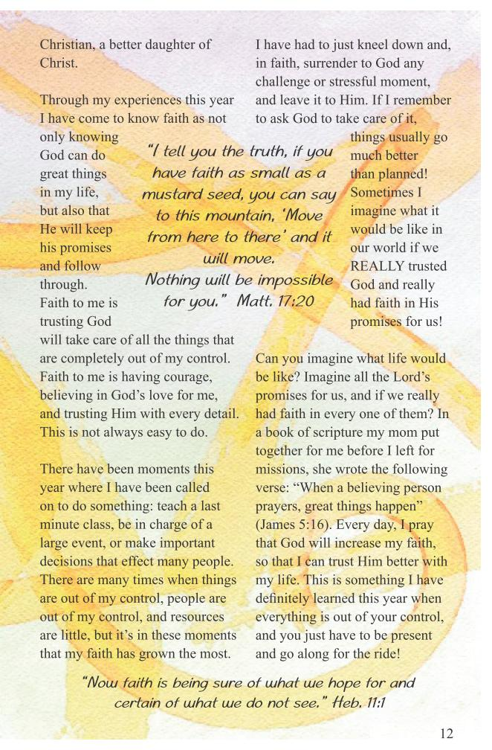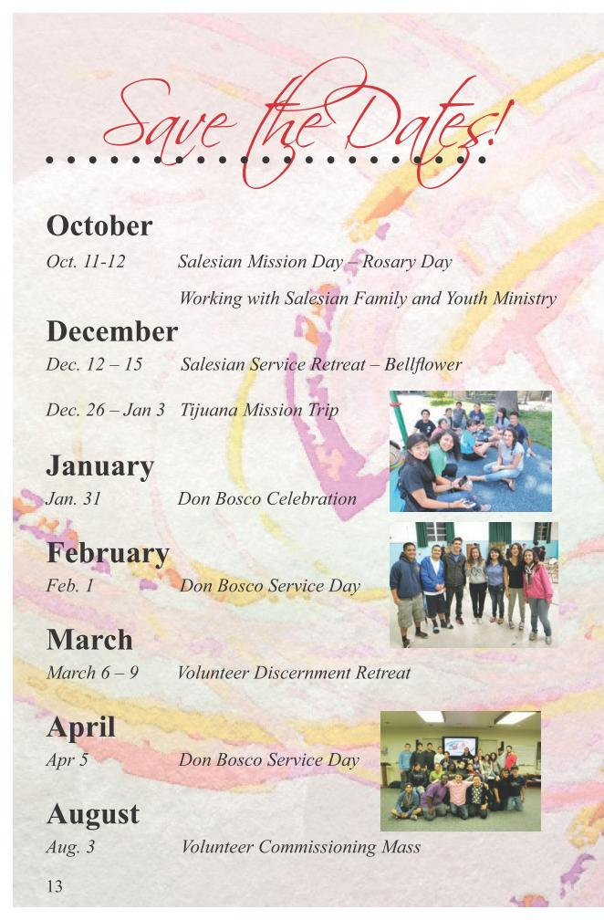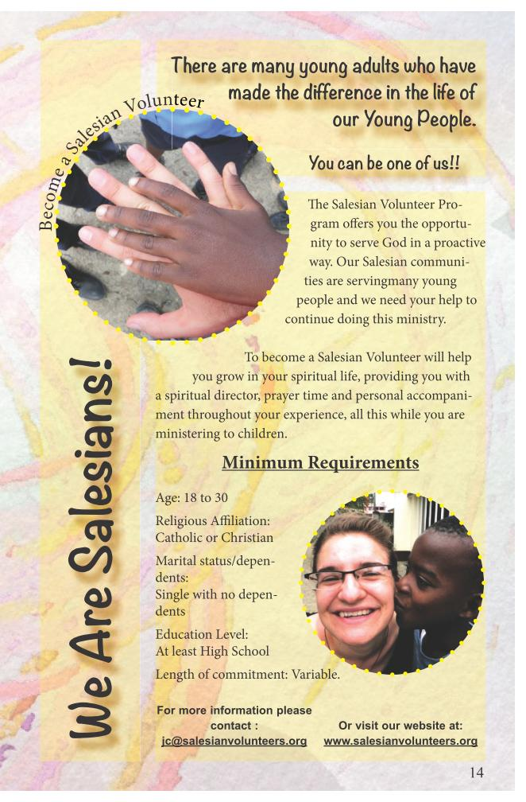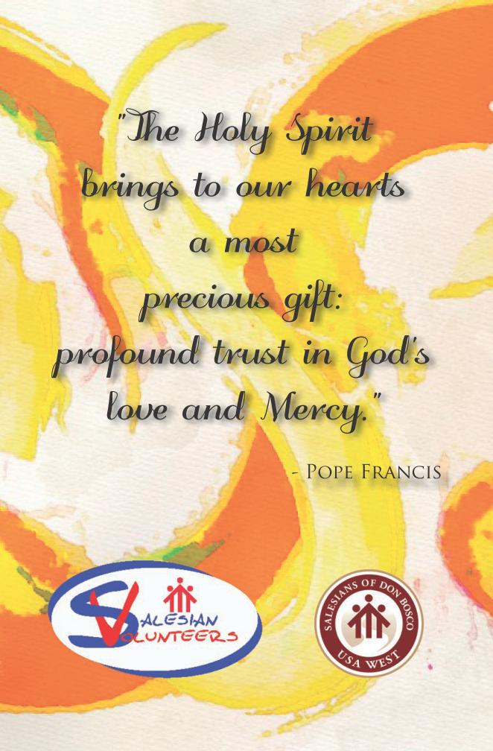
SVCF Salesian Volunteers Crossing Frontiers
Issue #31
Pg 2
Pgs 3-4
Pgs 5-6
Pgs 7-9
Pgs 9-11
Pgs 12-14
Intro to the Mission
Faith Through the Eyes of a Teenager
Searching for Meaning
Living in Community with Fr. Mike
Letting Go and Letting God
Real Faith
Juan Carlos Montenegro
Karley Porras
Joe Rodriguez
Justin Antoine Fontenot
Lorena Zamora
Jessie Smith
Graphic Designers
Giovanni Fernandez
Juan Carlos Montenegro
Editor
Judy Wilber Alvarez
Background and Cover Art
Giovanni Fernandez
If you are interested in submitting a volunteer expirience article please
contact Juan Carlos at: jc@salesianvolunteers.org
Table of Contents2
Juan Carlos Montenegro
St. Dominic Savio Youth Minister
Salesian Mission Animations Director
I have been thinking about the word “Faith”. What does it really mean? Can the word “faith” be a verb? An action?
Does faith mean that we need to just sit down and pray for things to happen? I have come to realize that our faith can be shown by the way we interact with one another; by the opportunities we cre- ate for our young people to encounter and develop their relation- ship with God.
The bible says “Fear not, beloved, you are safe; take courage and be strong” Daniel 10:19. To me, what to “take courage”with faith, means to be courageous enough to go encounter our youth. This is the time whenwe need to embrace our faith and use that courage that we are blessed to have.
This magazine is an example of how different people live their faith in action. I hope you enjoy the articles written for you. Please use them to help young people to understand their Vocational Call.
In Don Bosco your friend, Faith in ActionC uriosity. It’s a trait all hu- mans have. We wonder how things work, how to ? x things that are broken, what will make a better tomorrow, and many other ques- tions. Humans are curious all throughout life, but there is a time when it seems more questions are asked, more answers are wanted. It’s the time when youth start trying to ? nd them- selves, their place in the world, and what they believe in. It’s called being a teen- ager.
“Who is God?” “Where is the proof He is there?” “If God we are very vulner- able. So many things can in? uence us at this time, and make our futures different. How can we know what the right thing to believe in is? The Church’s por- trayal in the media often times doesn’t help a teenager have faith. Many times the Church is made out to be something that is too old and too traditional for our changing times. As a consequence, many teenagers shy away from the subject of faith or religion, for fear of what others may think. It is sad that some teenagers do that, because if Faith Through the Eyes of a Teenager Karley Porras 3 is there, why doesn’t he stop all the prob- lems in our world?” These are all ques- tions many teenagers ask at some point. Faith is something that is very hard for a teenager to grasp because, “Why should I believe in something I can’t see?” Many teenagers won’t admit it, but during this cru- cial time in our life, they knew God and trusted in him, they would have no reason to be afraid of what others think of their faith.
Even though many teenagers are lost dur- ing this time, and are still discovering what to believe in, there are those who know God and are able to have faith in him. God gave us all free will so that we may choose to be- lieve in whatever we please, with the hope that we would choose to believe in him. I am lucky enough to see teenagers in my 4 everyday life that have made the choice to believe in God and accept him. I am very blessed to be- long to a parish that has touched the lives of many teenagers and they have grown to touch the lives of those around them. Seeing what can hap- pen when you have faith makes you see things in a different way; it even makes you de? ne faith in a different way. The textbook de? nition of faith is an, “allegiance or duty to a person,” but I de? ne faith as trusting and loving something you believe in. I may not be able to see God like I see the people around me, but I keep my faith in him because I see him everywhere. I see him whenever a child is born, a couple married, a person’s life is saved, and even when a ? ower blooms. Each one of these is an example of God being there in my life. Each one is an example of why I have faith. And most importantly, each one is an example of why I’m not afraid to say I am a Catholic.Searching For Meaning Joe Rodriguez Social Communications Delegate N ot that long ago, before becoming a Salesian, a great part of my life was traveling to different cities and states, putting on Catholic evan- gelization retreats for youth. It was a time when I saw the seeds of conversion and reconcilia- tion being planted in the young. On rare occasions I would also see some of these young people answer God’s call to the religious life. During this time I felt God calling me to settle down and plant my roots in my parish. My wife and I soon registered our daughter at St Dominic Savio School. My wife volunteered her time in the Church Of? ce, and I volunteered my time as a member of the Finance Committee and later as a catechist. During this drastic transition, Sr. Mary gave my wife a book to read. The book was the story of St. John Bosco, written by Pe- ter Lapin and called “Give Me Souls.” I could not put the book down, but would stay up late at night, devouring each word and sentence. I was so fascinated by his life and the work he was do- ing with youth. After read- ing the book, my wife and I felt called to be Salesian Coopera- tors. Soon we began the formation process and 5"We are all called to be missionaries of our own surroundings" within a short period of time we were inducted. It was a joyful moment in my life. However, it wasn’t too long after that I en- countered the reality of my situ- ation. Somehow my reading of the life of Don Bosco placed high expectations that were not being met. I had a hard time reconcil- ing St. John Bosco’s life and how it applied to living today in the U.S.A. So I became disillusioned and questioned God, “Why am I here?” Well God answered my prayers one day when Juan Carlos Monte- negro came up to me and invited me to come to the Salesian Orato- ries in Tijuana, Mexico. I agreed to go and we accompanied about 20 young people. The experience was so powerful for me that I was able see St. John Bosco alive in today’s times, as we were serv- ing the poor. My life as a Salesian was renewed and my zeal for the missions increased. Now what I see today in the Volunteer program is not so much the actual visiting of sites, and the spiritual experience gained by it, but rather all the nurturing that takes place before it. We call this accompaniment. It’s the work of all who help create small steps in the lives of the young while they are in school, learning to be mis- sionaries in their surroundings, sometimes as small as collect- ing change and bringing it to the teacher.
Kudos to all who continue to teach in small or large ways - to those who are sowing and to oth- ers who are reaping. 6B eing a priest has lots of responsibilities and expectations. As pastor of San Luis Rey Church in Laredo, Texas, Fr. Mike has been given a little bit more. Like all priests he celebrates mass on Sundays, hears confessions, and presides over baptisms, marriages and funerals. But he also does the church bulletins every week and will even pull up his sleeves and get his hands dirty with more manual labor-type work. Before Fr. Ata arrived from Spain, Fr. Raul was the only Salesian priest to assist Fr. Mike at San Luis Rey. Whenever Fr. Raul would travel for his Marriage Encounter trips, Fr. Mike would celebrate every single mass on Sunday by himself! If such dedication isn’t evidence of a man with so much faith and love for his parish and community, I don’t know what is. Before coming to Laredo, Fr. Mike spent two years in Guadalajara, Mexico. In those two years he learned to speak Spanish and share his faith in the native tongue, which he still does today at San Luis Rey. In the six months I’ve spent here in Laredo, I’ve learned quite a bit from Fr. Mike, such as easy and smarter ways of doing certain Living in Community with Fr. Mike A Volunteer Story By Justin Antoine Fontenot 7tasks, more background about Don Bosco, and answers to questions I’ve had about living out my faith. I once asked him why he decided to become a Salesian priest and his simple response was, “I wanted to be a teacher.” Although he doesn’t get to teach in a classroom setting in his current position, he can’t help but teach you something when you interact with him. During our times at lunch I’ve had my share of learning history, religion, and lots of Spanish. This whole experience has changed my life. Before coming to Laredo I didn’t feel like I was doing enough for others or for myself. Now I’m in better physical shape, have come to terms with my past, and have grown spiritually. I’m ful? lled and faith-? lled. As my year of volunteer service is coming to an end, I’ve considered different options as my next step. One of those options is to enter into the Salesian formation program. Living in community with Fr. Mike, and seeing how he and the other Salesian priests interact with the people, has furthered my own interest in maybe becoming a Salesian myself. As a Salesian, Fr. Mike truly is an example of the spirit of Don Bosco. I myself have been inspired by his faith in this little town and his faith in God. If I am to be a Salesian someday, I hope to be at least half as faithful as this father, worker and teacher named Fr. Mike Gergen.
8I have been in Okinawa, Bo- livia as a Salesian Lay Mis- sioner for 8 months, and they have been the most ful? lling and best 8 months of my life. While being here, I have realized that to continue working as a missionary you need faith, extreme faith. I ? nd myself telling people, “If I didn’t have my faith, there is no way I would be able to be here and work.” God has de? nitely been my num- ber one companion along this jour- Letting Go and Letting God Lorena Zamora ney. He has been holding my hand these past 8 months, and I know He will keep holding my hand for the next 4 upcoming months. There are many hardships I have had to go through and I am still going through while being here. Though I may not understand why certain things happen, I have faith in my God and I know that there is a reason why they are happening. I believe the Lord has a plan for me. I will say that my faith has 9increased so much more while in Bolivia. I have always had trouble let- ting go, and letting God. I always felt that I need- ed to be in control of my life and it bothered me when I wasn’t. Because of that attitude, I would eventually end up hurting myself or end up broken- hearted. I have to keep reminding myself that God is in control and not me. To be honest my faith does get challenged a lot, especially here, and it’s very hard to accept what God wants from me. Often times I really don’t understand what God’s plan is for me. When at times I feel confused, upset or lonely, God has a way of manifesting Himself in the kids with whom I work. They show me so much love, love I have never experienced before, and that’s how I know He is here with me, by my side. I have faith in Him that in the end, everything will turn out alright, and that I am becoming a much better person than I was before, having this ex- perience just the way He planned it. I‘m letting go and letting God.
10A s a missionary in Tijuana this year, I have thought a lot about the concept of faith. I have thought about what it means to me, and what it means to the people who have come into my life during this year of missions. Sometimes I am amazed at the great faith people have that God will take care of them in their trials. I have taken this as a great lesson from the people I have been blessed to meet here. Their ability to live in the present and trust God has inspired me to hope and believe in God’s promises for me, and all of us, in a greater way. What does faith mean to me? How has faith been a part of my missionary experience? Well, without it, I would not be here. I would not be ? lled with the joy that I have experienced, and I would not have a purpose as a missionary! Taking the step to be a missionary was, ? rst of all, a step of faith, because I had to trust that God was calling me to do something in an unfamiliar place, and trust that He would guide me through it all! From the moment I left my job, my home, and my family, and stepped on the airplane to come to the missions, until this very moment 8 months later, God has guided me faithfully. Not only has He guided me, but pleasantly surprised me with many things! Even in moments when I don’t feel Him near and don’t understand His plan, I recognize the need to have real and genuine faith, that every challenge, every trial is to help me grow. I have to trust during the trial, and have faith that He will lead me through it, changing me into a better person, a better Real Faith By: Jessie Smith 1112 Christian, a better daughter of Christ. Through my experiences this year I have come to know faith as not only knowing God can do great things in my life, but also that He will keep his promises and follow through. Faith to me is trusting God will take care of all the things that are completely out of my control. Faith to me is having courage, believing in God’s love for me, and trusting Him with every detail. This is not always easy to do. There have been moments this year where I have been called on to do something: teach a last minute class, be in charge of a large event, or make important decisions that effect many people. There are many times when things are out of my control, people are out of my control, and resources are little, but it’s in these moments that my faith has grown the most. I have had to just kneel down and, in faith, surrender to God any challenge or stressful moment, and leave it to Him. If I remember to ask God to take care of it, things usually go much better than planned! Sometimes I imagine what it would be like in our world if we REALLY trusted God and really had faith in His promises for us! Can you imagine what life would be like? Imagine all the Lord’s promises for us, and if we really had faith in every one of them? In a book of scripture my mom put together for me before I left for missions, she wrote the following verse: “When a believing person prayers, great things happen” (James 5:16). Every day, I pray that God will increase my faith, so that I can trust Him better with my life. This is something I have de? nitely learned this year when everything is out of your control, and you just have to be present and go along for the ride! “I tell you the truth, if you have faith as small as a mustard seed, you can say to this mountain, ‘Move from here to there’ and it will move. Nothing will be impossible for you.” Matt. 17:20 “Now faith is being sure of what we hope for and certain of what we do not see.” Heb. 11:113 Save the Dates!
October
Oct. 11-12 Salesian Mission Day – Rosary Day
Working with Salesian Family and Youth Ministry
December
Dec. 12 – 15 Salesian Service Retreat – Bell? ower
Dec. 26 – Jan 3 Tijuana Mission Trip
January
Jan. 31 Don Bosco Celebration
February
Feb. 1 Don Bosco Service Day
March
March 6 – 9 Volunteer Discernment Retreat
April
Apr 5 Don Bosco Service Day
August
Aug. 3 Volunteer Commissioning Mass14
Become a Salesian Volunteer e Salesian Volunteer Pro- gram o- ers you the opportu- nity to serve God in a proactive way. Our Salesian communi- ties are servingmany young people and we need your help to continue doing this ministry.
To become a Salesian Volunteer will help you grow in your spiritual life, providing you with a spiritual director, prayer time and personal accompani- ment throughout your experience, all this while you are ministering to children.
Minimum Requirements Age: 18 to 30 Religious A liation: Catholic or Christian Marital status/depen- dents: Single with no depen- dents Education Level: At least High School Length of commitment: Variable.
We Are Salesians!
You can be one of us!!
There are many young adults who have made the difference in the life of our Young People.
For more information please contact : jc@salesianvolunteers.org Or visit our website at: www.salesianvolunteers.org"The Holy Spirit brings to our hearts a most precious gift: profound trust in God's love and Mercy." - Pope Francis

