-1- -2- -3- -4- -5- -6- -7- -8- -9- -10- -11- -12- -13- -14- -15- -16- -17- -18- -19- -20- -21- -22- -23- -24- -25- -26- -27- -28- -29- -30- -31- -32- 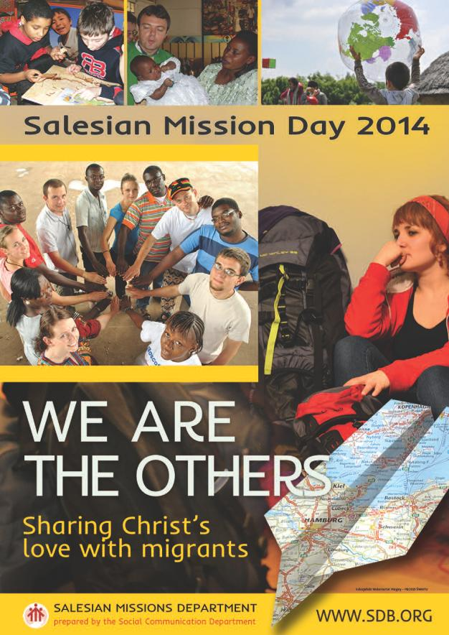- 2- -1- 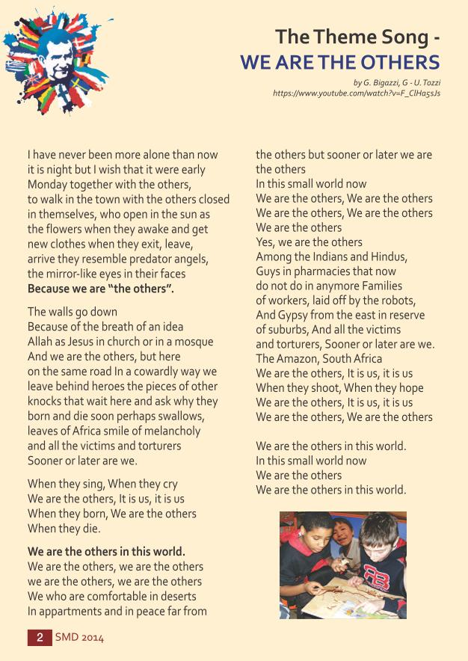-3- -2- 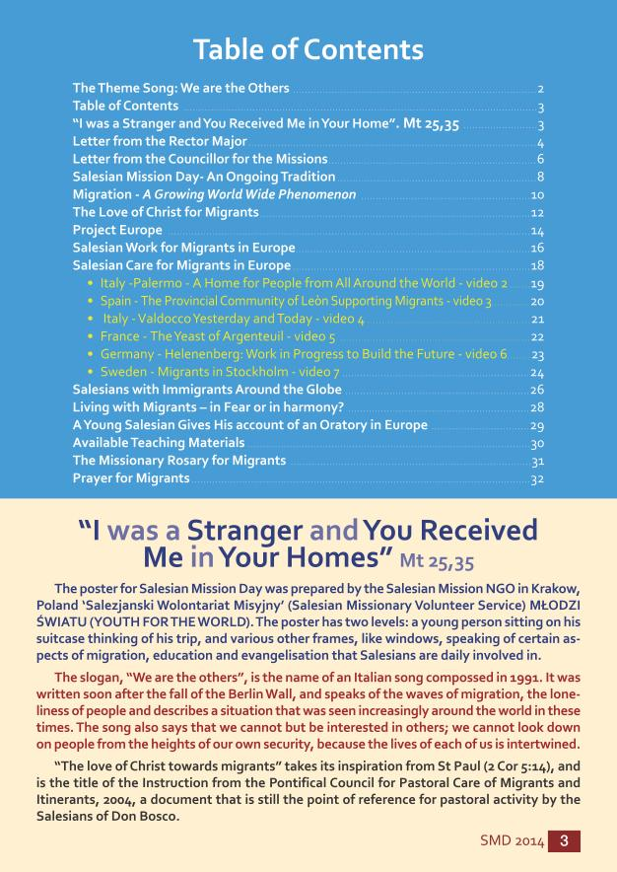-4- -3- 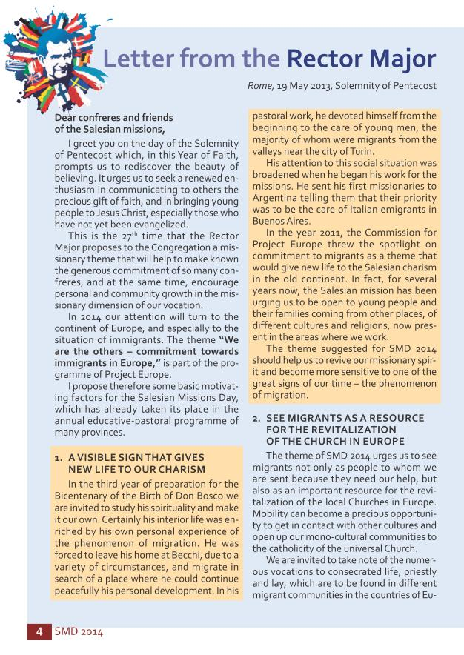-5- -4- 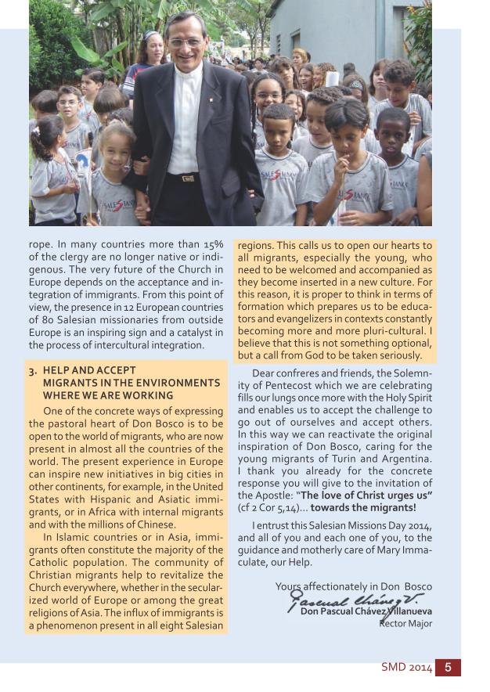-6- -5- 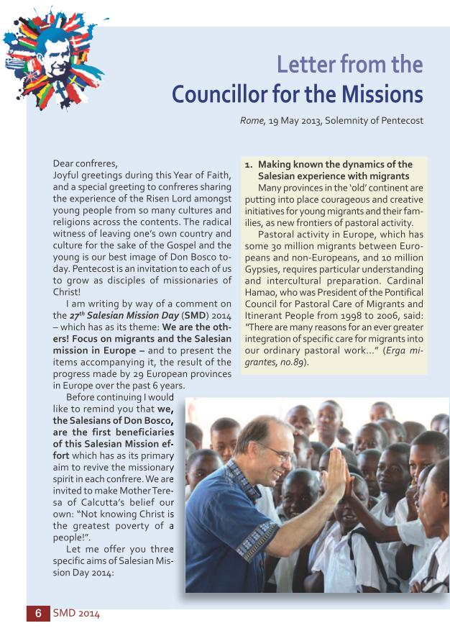-7- -6- 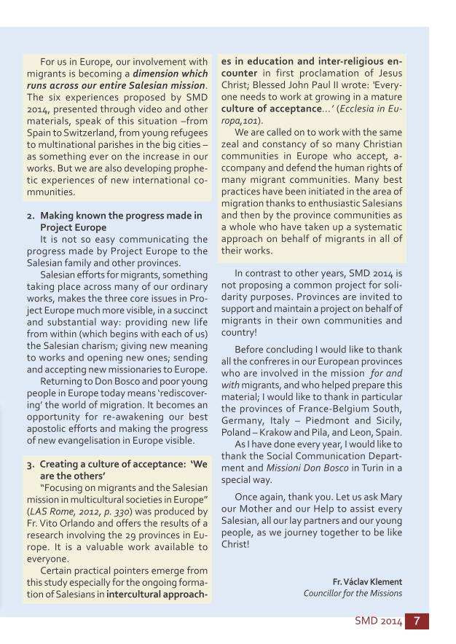-8- -7- 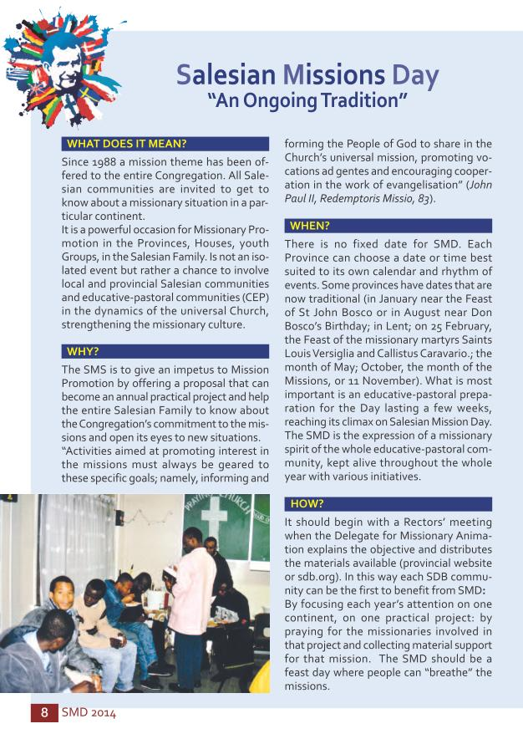-9- -8- 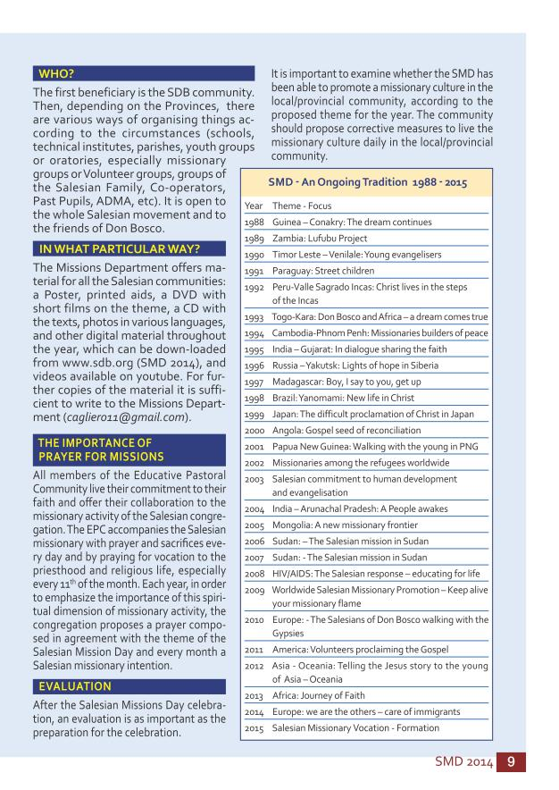-10- -9- 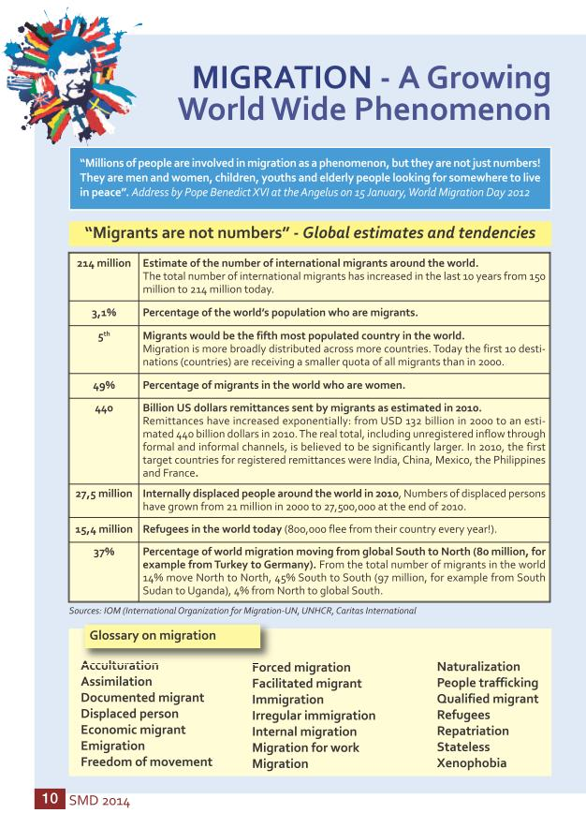-11- -10- 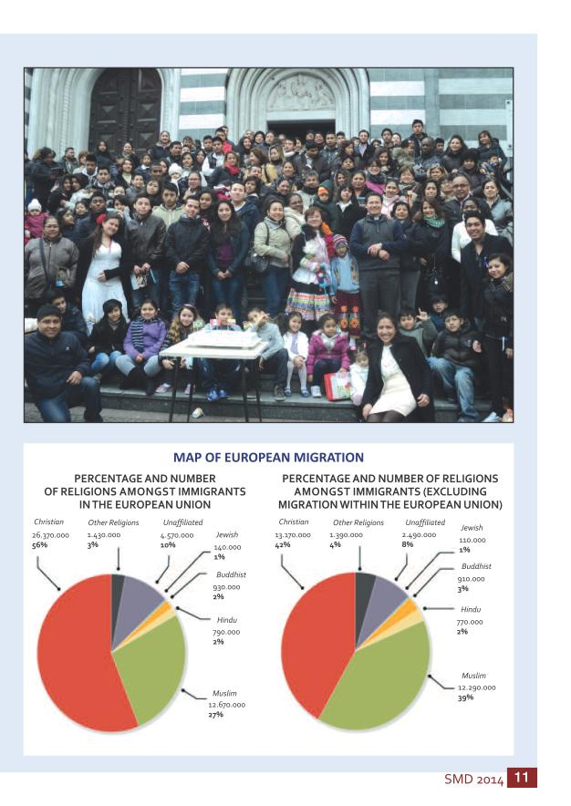-12- -11- 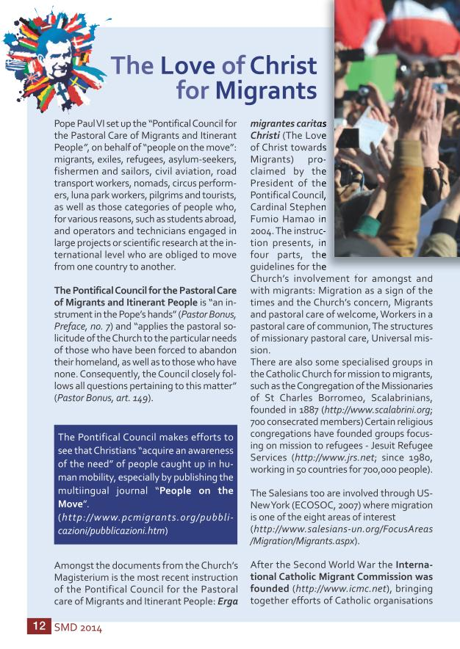-13- -12- 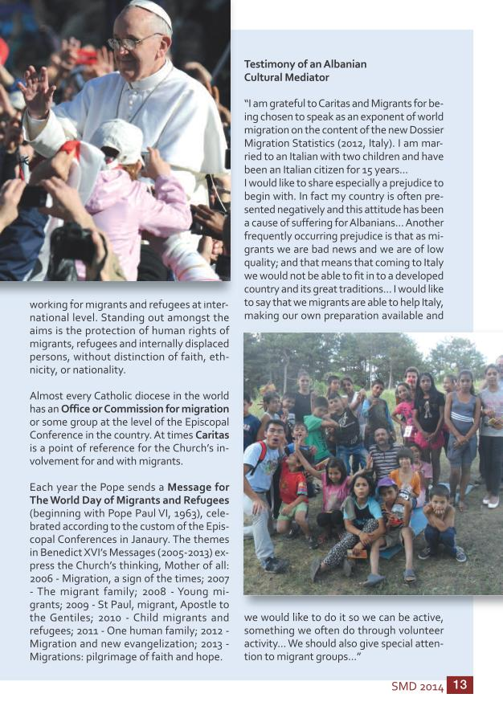-14- -13- 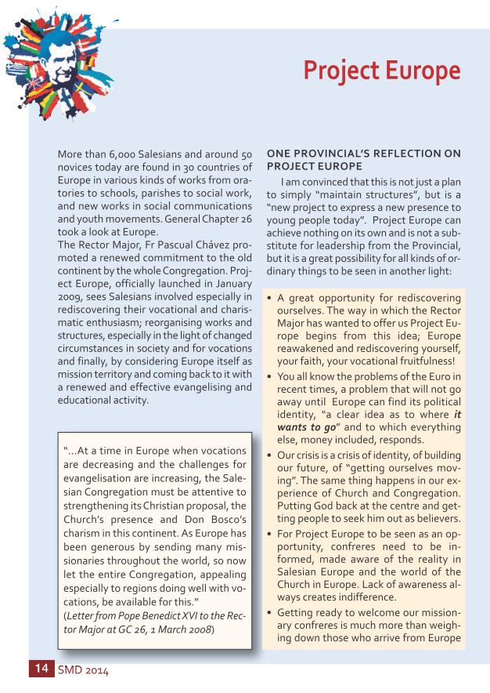-15- -14- 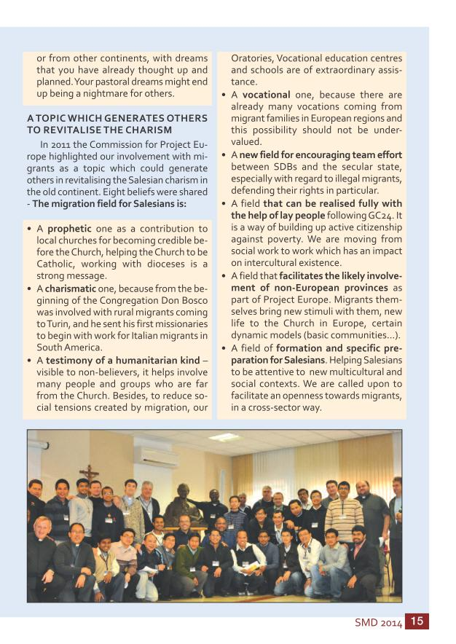-16- -15- 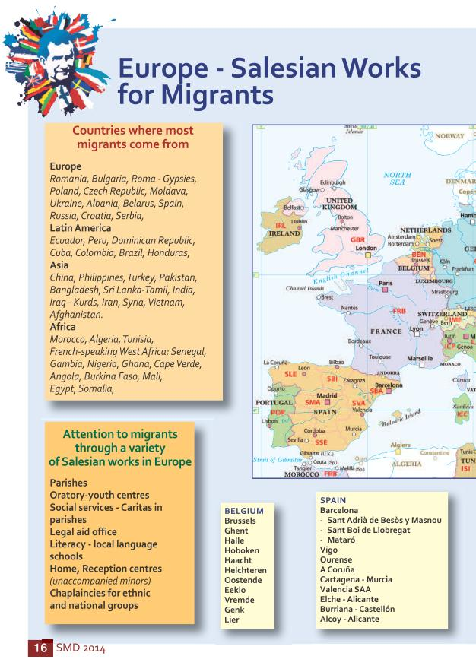-17- -16- 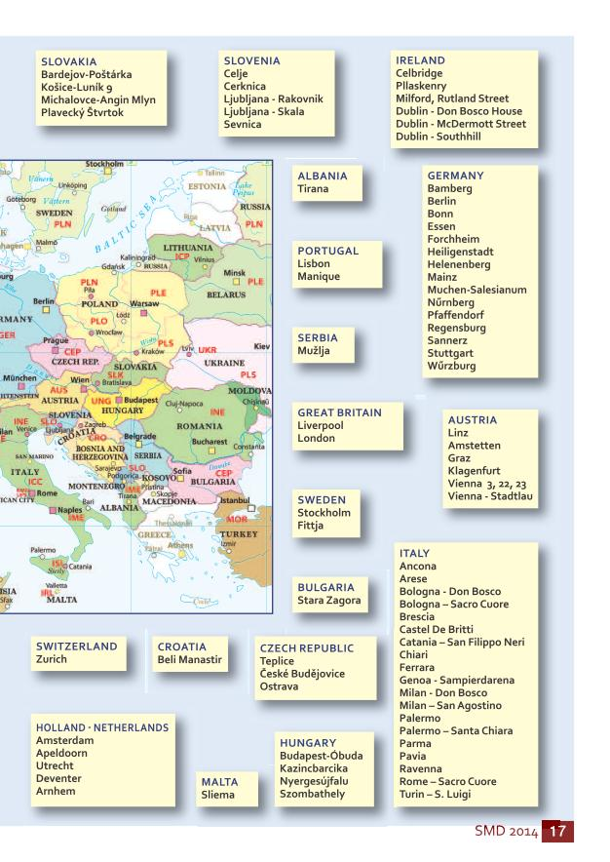-18- -17- 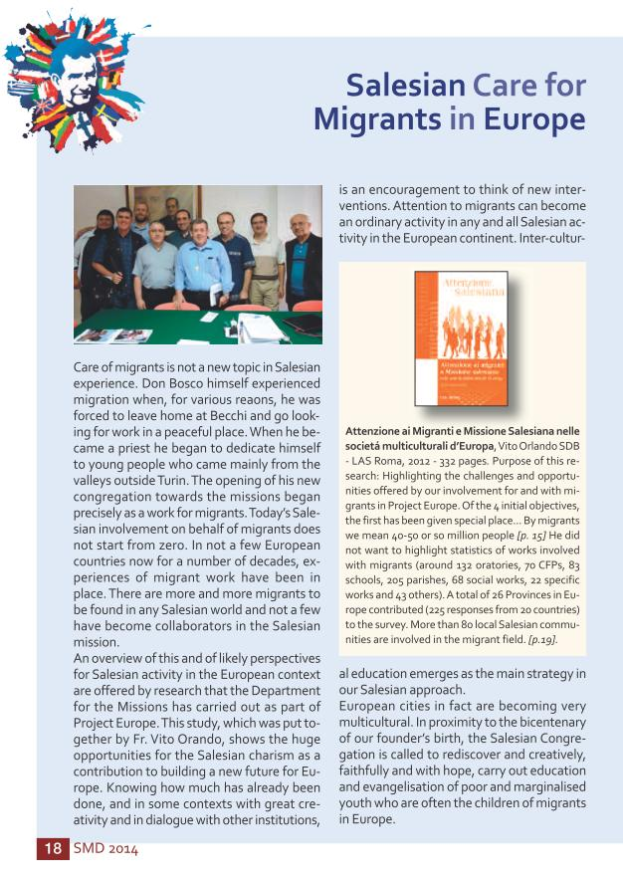-19- -18- 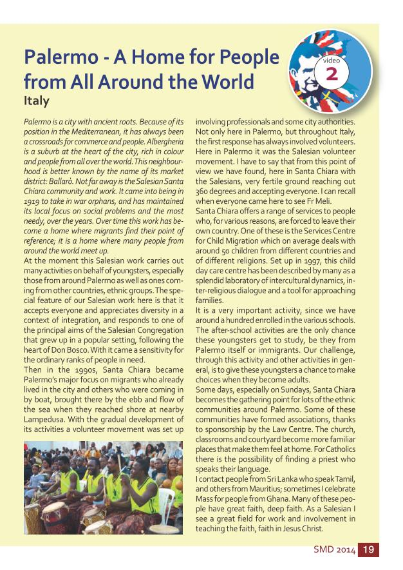-20- -19- 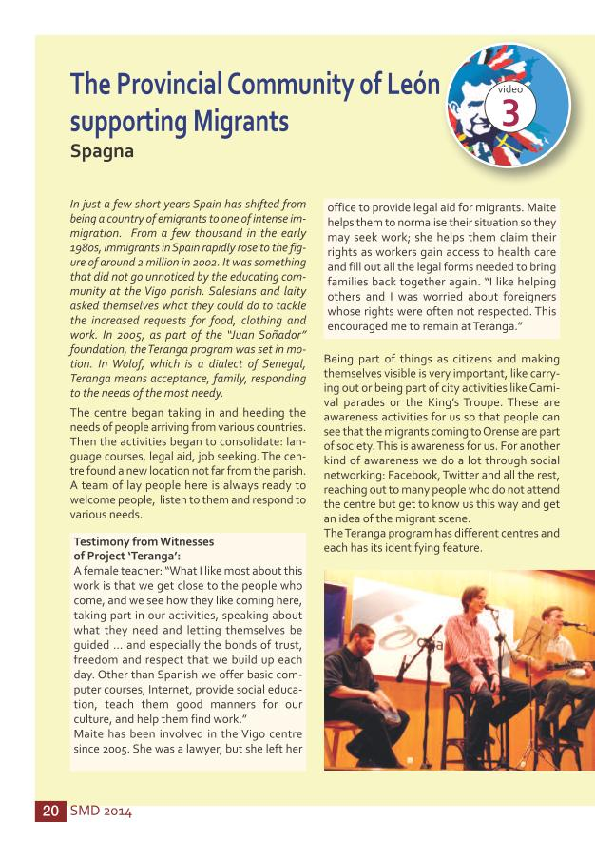-21- -20- 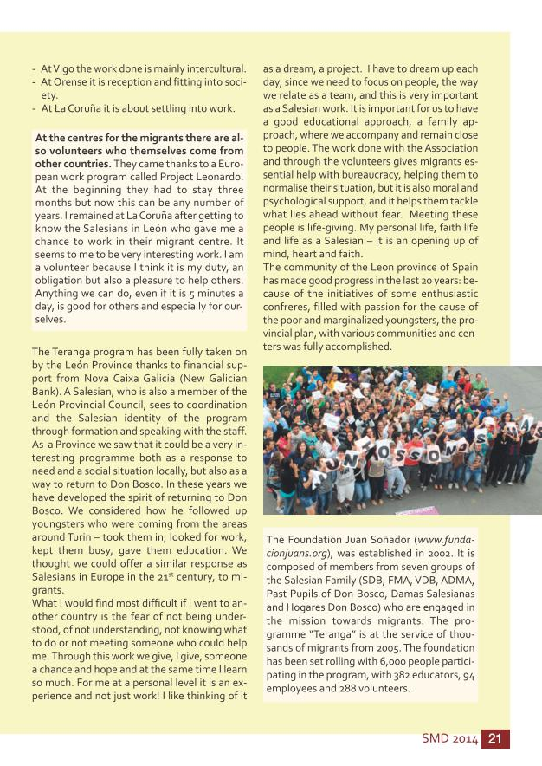-22- -21- 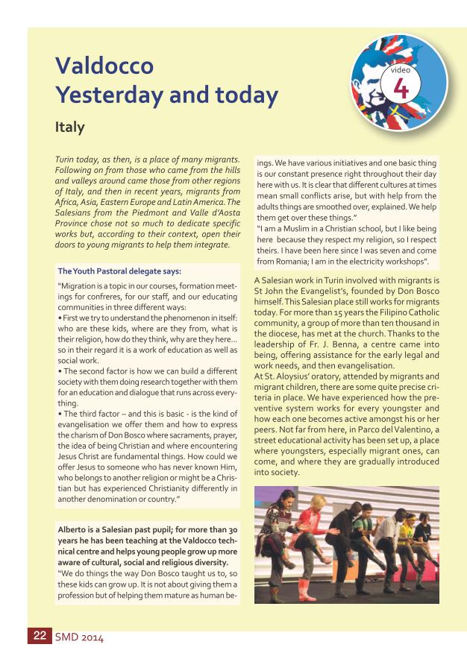-23- -22- 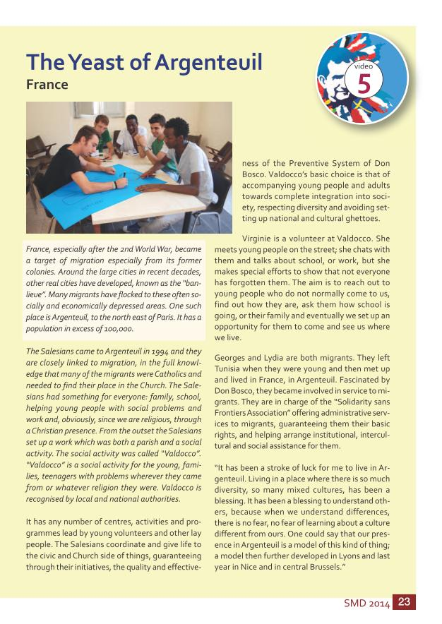-24- -23- 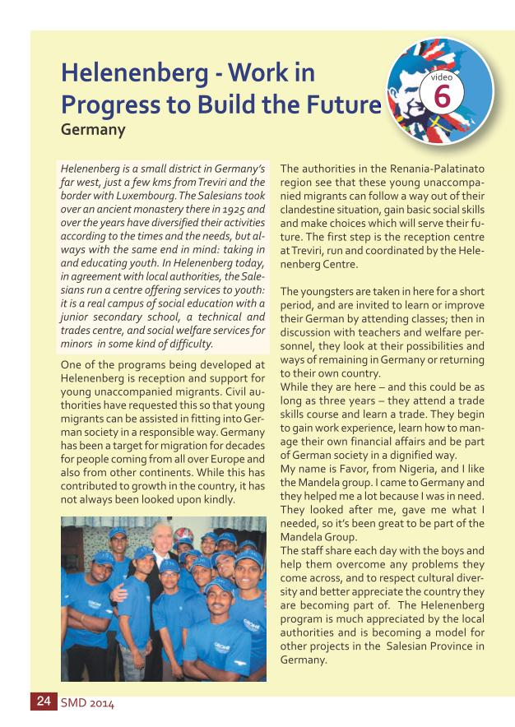-25- -24- 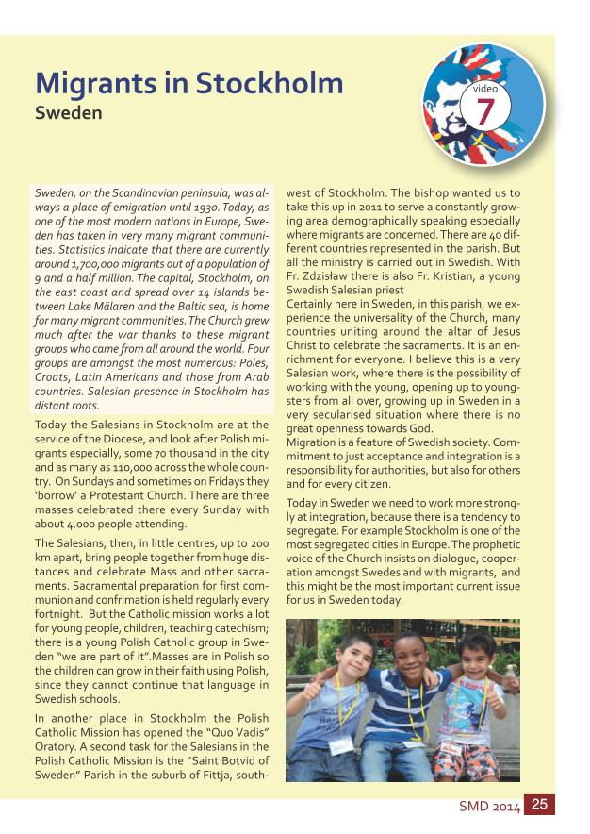-26- -25- 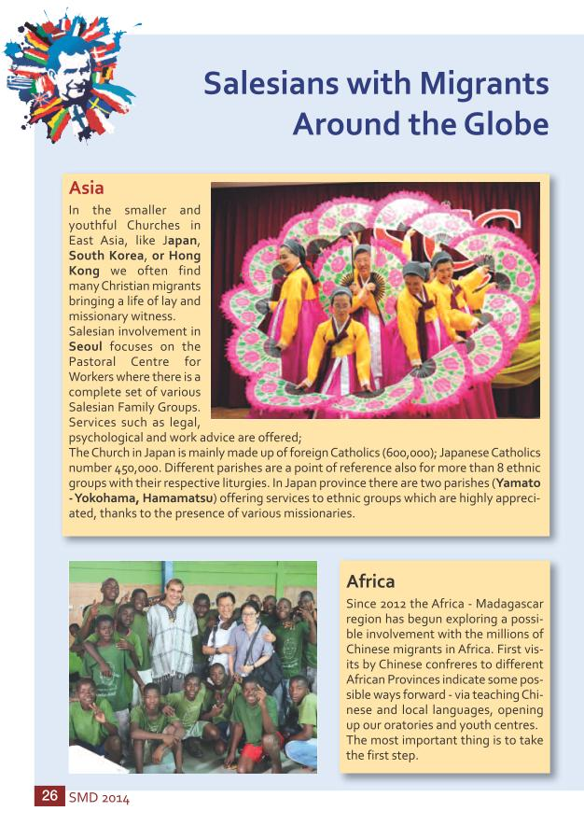-27- -26- 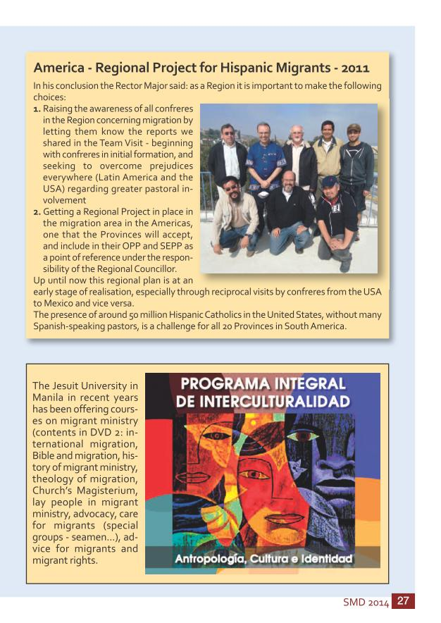-28- -27- 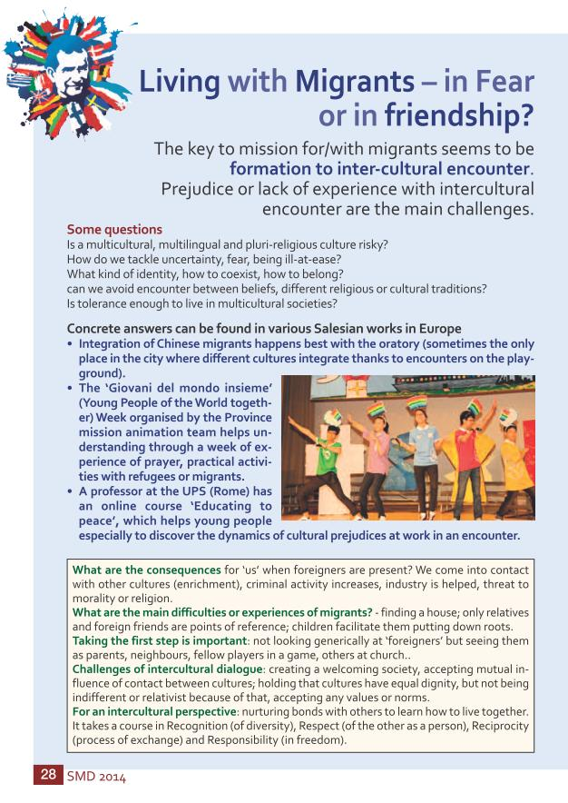-29- -28- 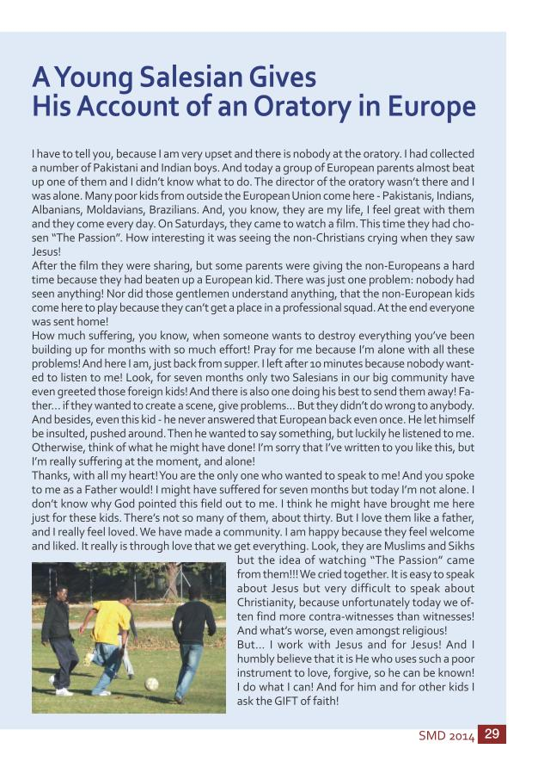-30- -29- 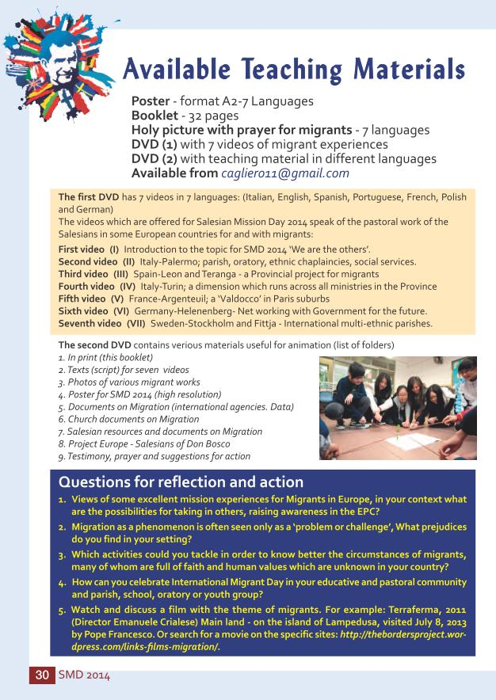-31- -30- 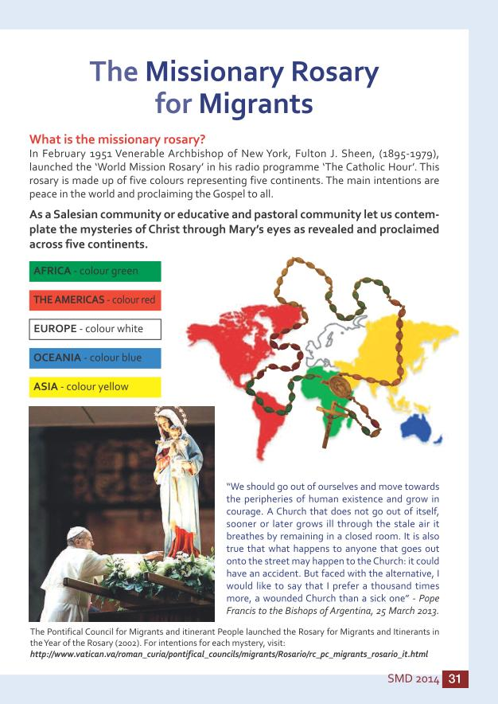-32- -31- 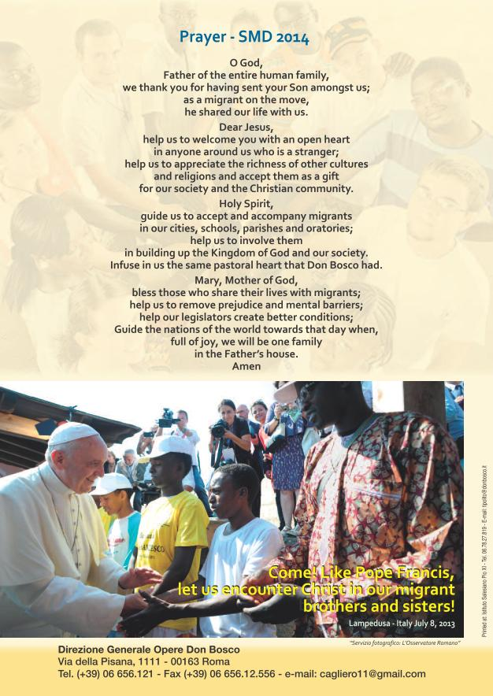
SMD 2014 2 The Theme Song - WE ARE THE OTHERS by G. Bigazzi, G - U. Tozzi https://www.youtube.com/watch?v=F_ClHa5sJs I have never been more alone than now it is night but I wish that it were early Monday together with the others, to walk in the town with the others closed in themselves, who open in the sun as the flowers when they awake and get new clothes when they exit, leave, arrive they resemble predator angels, the mirror-like eyes in their faces Because we are “the others”.
The walls go down Because of the breath of an idea Allah as Jesus in church or in a mosque And we are the others, but here on the same road In a cowardly way we leave behind heroes the pieces of other knocks that wait here and ask why they born and die soon perhaps swallows, leaves of Africa smile of melancholy and all the victims and torturers Sooner or later are we.
When they sing, When they cry We are the others, It is us, it is us When they born, We are the others When they die.
We are the others in this world.
We are the others, we are the others we are the others, we are the others We who are comfortable in deserts In appartments and in peace far from the others but sooner or later we are the others In this small world now We are the others, We are the others We are the others, We are the others We are the others Yes, we are the others Among the Indians and Hindus, Guys in pharmacies that now do not do in anymore Families of workers, laid off by the robots, And Gypsy from the east in reserve of suburbs, And all the victims and torturers, Sooner or later are we.
The Amazon, South Africa We are the others, It is us, it is us When they shoot, When they hope We are the others, It is us, it is us We are the others, We are the others We are the others in this world.
In this small world now We are the others We are the others in this world.Table of Contents The Theme Song: We are the Others . . . . . . . . . . . . . . . . . . . . . . . . . . . . . . . . . . . . . . . . . . . . . . . . . . . . . . . . . . . . . . . . . . . . . . . . . . . . . . . . . . 2 Table of Contents . . . . . . . . . . . . . . . . . . . . . . . . . . . . . . . . . . . . . . . . . . . . . . . . . . . . . . . . . . . . . . . . . . . . . . . . . . . . . . . . . . . . . . . . . . . . . . . . . . . . . . . . . . . . . . . . . . . . . . . 3 “I was a Stranger and You Received Me in Your Home”. Mt 25,35 . . . . . . . . . . . . . . . . . . . . . . . . . 3 Letter from the Rector Major . . . . . . . . . . . . . . . . . . . . . . . . . . . . . . . . . . . . . . . . . . . . . . . . . . . . . . . . . . . . . . . . . . . . . . . . . . . . . . . . . . . . . . . . . . . . . . . . . 4 Letter from the Councillor for the Missions . . . . . . . . . . . . . . . . . . . . . . . . . . . . . . . . . . . . . . . . . . . . . . . . . . . . . . . . . . . . . . . . . . . . . . 6 Salesian Mission Day- An Ongoing Tradition . . . . . . . . . . . . . . . . . . . . . . . . . . . . . . . . . . . . . . . . . . . . . . . . . . . . . . . . . . . . . . . . . . . 8 Migration - A Growing World Wide Phenomenon . . . . . . . . . . . . . . . . . . . . . . . . . . . . . . . . . . . . . . . . . . . . . . . . . . . . . . . . . 10 The Love of Christ for Migrants . . . . . . . . . . . . . . . . . . . . . . . . . . . . . . . . . . . . . . . . . . . . . . . . . . . . . . . . . . . . . . . . . . . . . . . . . . . . . . . . . . . . . . . . . . . 12 Project Europe . . . . . . . . . . . . . . . . . . . . . . . . . . . . . . . . . . . . . . . . . . . . . . . . . . . . . . . . . . . . . . . . . . . . . . . . . . . . . . . . . . . . . . . . . . . . . . . . . . . . . . . . . . . . . . . . . . . . . . . . . . 14 Salesian Work for Migrants in Europe . . . . . . . . . . . . . . . . . . . . . . . . . . . . . . . . . . . . . . . . . . . . . . . . . . . . . . . . . . . . . . . . . . . . . . . . . . . . . . . 16 Salesian Care for Migrants in Europe . . . . . . . . . . . . . . . . . . . . . . . . . . . . . . . . . . . . . . . . . . . . . . . . . . . . . . . . . . . . . . . . . . . . . . . . . . . . . . . . 18 • Italy -Palermo - A Home for People from All Around the World - video 2 . . . . . . . 19 • Spain - The Provincial Community of Leòn Supporting Migrants - video 3 . . . . . . . . . . . . . 20 • Italy - ValdoccoYesterday and Today - video 4 . . . . . . . . . . . . . . . . . . . . . . . . . . . . . . . . . . . . . . . . . . . . . . . . . . . . . . . 21 • France - The Yeast of Argenteuil - video 5 . . . . . . . . . . . . . . . . . . . . . . . . . . . . . . . . . . . . . . . . . . . . . . . . . . . . . . . . . . . . . . . . 22 • Germany - Helenenberg: Work in Progress to Build the Future - video 6 . . . . . . . . 23 • Sweden - Migrants in Stockholm - video 7 . . . . . . . . . . . . . . . . . . . . . . . . . . . . . . . . . . . . . . . . . . . . . . . . . . . . . . . . . . . . . . . 24 Salesians with Immigrants Around the Globe . . . . . . . . . . . . . . . . . . . . . . . . . . . . . . . . . . . . . . . . . . . . . . . . . . . . . . . . . . . . . . 26 Living with Migrants – in Fear or in harmony? . . . . . . . . . . . . . . . . . . . . . . . . . . . . . . . . . . . . . . . . . . . . . . . . . . . . . . . . . . . . . 28 A Young Salesian Gives His account of an Oratory in Europe . . . . . . . . . . . . . . . . . . . . . . . . . . . . . . . . . 29 Available Teaching Materials . . . . . . . . . . . . . . . . . . . . . . . . . . . . . . . . . . . . . . . . . . . . . . . . . . . . . . . . . . . . . . . . . . . . . . . . . . . . . . . . . . . . . . . . . . . . . . . 30 The Missionary Rosary for Migrants . . . . . . . . . . . . . . . . . . . . . . . . . . . . . . . . . . . . . . . . . . . . . . . . . . . . . . . . . . . . . . . . . . . . . . . . . . . . . . . . . 31 Prayer for Migrants . . . . . . . . . . . . . . . . . . . . . . . . . . . . . . . . . . . . . . . . . . . . . . . . . . . . . . . . . . . . . . . . . . . . . . . . . . . . . . . . . . . . . . . . . . . . . . . . . . . . . . . . . . . . . . . . . . 32 SMD 2014 The poster for Salesian Mission Day was prepared by the Salesian Mission NGO in Krakow, Poland ‘Salezjanski Wolontariat Misyjny’ (Salesian Missionary Volunteer Service) MŁODZI ŚWIATU (YOUTH FOR THE WORLD). The poster has two levels: a young person sitting on his suitcase thinking of his trip, and various other frames, like windows, speaking of certain as- pects of migration, education and evangelisation that Salesians are daily involved in.
The slogan, “We are the others”, is the name of an Italian song compossed in 1991. It was written soon after the fall of the Berlin Wall, and speaks of the waves of migration, the lone- liness of people and describes a situation that was seen increasingly around the world in these times. The song also says that we cannot but be interested in others; we cannot look down on people from the heights of our own security, because the lives of each of us is intertwined.
“The love of Christ towards migrants” takes its inspiration from St Paul (2 Cor 5:14), and is the title of the Instruction from the Pontifical Council for Pastoral Care of Migrants and Itinerants, 2004, a document that is still the point of reference for pastoral activity by the Salesians of Don Bosco.
3 “I was a Stranger and You Received Me in Your Homes” Mt 25,35SMD 2014 4 Letter from the Rector Major Rome, 19 May 2013, Solemnity of Pentecost Dear confreres and friends of the Salesian missions, I greet you on the day of the Solemnity of Pentecost which, in this Year of Faith, prompts us to rediscover the beauty of believing. It urges us to seek a renewed en- thusiasm in communicating to others the precious gift of faith, and in bringing young people to Jesus Christ, especially those who have not yet been evangelized.
This is the 27 th time that the Rector Major proposes to the Congregation a mis- sionary theme that will help to make known the generous commitment of so many con- freres, and at the same time, encourage personal and community growth in the mis- sionary dimension of our vocation. In 2014 our attention will turn to the continent of Europe, and especially to the situation of immigrants. The theme “We are the others – commitment towards immigrants in Europe,” is part of the pro- gramme of Project Europe.
I propose therefore some basic motivat- ing factors for the Salesian Missions Day, which has already taken its place in the annual educative-pastoral programme of many provinces.
1. A VISIBLE SIGN THAT GIVES NEW LIFE TO OUR CHARISM In the third year of preparation for the Bicentenary of the Birth of Don Bosco we are invited to study his spirituality and make it our own. Certainly his interior life was en- riched by his own personal experience of the phenomenon of migration. He was forced to leave his home at Becchi, due to a variety of circumstances, and migrate in search of a place where he could continue peacefully his personal development. In his pastoral work, he devoted himself from the beginning to the care of young men, the majority of whom were migrants from the valleys near the city of Turin.
His attention to this social situation was broadened when he began his work for the missions. He sent his first missionaries to Argentina telling them that their priority was to be the care of Italian emigrants in Buenos Aires.
In the year 2011, the Commission for Project Europe threw the spotlight on commitment to migrants as a theme that would give new life to the Salesian charism in the old continent. In fact, for several years now, the Salesian mission has been urging us to be open to young people and their families coming from other places, of different cultures and religions, now pres- ent in the areas where we work. The theme suggested for SMD 2014 should help us to revive our missionary spir- it and become more sensitive to one of the great signs of our time – the phenomenon of migration.
2. SEE MIGRANTS AS A RESOURCE FOR THE REVITALIZATION OF THE CHURCH IN EUROPE The theme of SMD 2014 urges us to see migrants not only as people to whom we are sent because they need our help, but also as an important resource for the revi- talization of the local Churches in Europe.
Mobility can become a precious opportuni- ty to get in contact with other cultures and open up our mono-cultural communities to the catholicity of the universal Church.
We are invited to take note of the numer- ous vocations to consecrated life, priestly and lay, which are to be found in different migrant communities in the countries of Eu-SMD 2014 5 rope. In many countries more than 15% of the clergy are no longer native or indi- genous. The very future of the Church in Europe depends on the acceptance and in- tegration of immigrants. From this point of view, the presence in 12 European countries of 80 Salesian missionaries from outside Europe is an inspiring sign and a catalyst in the process of intercultural integration. 3. HELP AND ACCEPT MIGRANTS IN THE ENVIRONMENTS WHERE WE ARE WORKING One of the concrete ways of expressing the pastoral heart of Don Bosco is to be open to the world of migrants, who are now present in almost all the countries of the world. The present experience in Europe can inspire new initiatives in big cities in other continents, for example, in the United States with Hispanic and Asiatic immi- grants, or in Africa with internal migrants and with the millions of Chinese. In Islamic countries or in Asia, immi- grants often constitute the majority of the Catholic population. The community of Christian migrants help to revitalize the Church everywhere, whether in the secular- ized world of Europe or among the great religions of Asia. The influx of immigrants is a phenomenon present in all eight Salesian regions. This calls us to open our hearts to all migrants, especially the young, who need to be welcomed and accompanied as they become inserted in a new culture. For this reason, it is proper to think in terms of formation which prepares us to be educa- tors and evangelizers in contexts constantly becoming more and more pluri-cultural. I believe that this is not something optional, but a call from God to be taken seriously.
Dear confreres and friends, the Solemn- ity of Pentecost which we are celebrating fills our lungs once more with the Holy Spirit and enables us to accept the challenge to go out of ourselves and accept others. In this way we can reactivate the original inspiration of Don Bosco, caring for the young migrants of Turin and Argentina. I thank you already for the concrete response you will give to the invitation of the Apostle: “The love of Christ urges us” (cf 2 Cor 5,14)... towards the migrants!
I entrust this Salesian Missions Day 2014, and all of you and each one of you, to the guidance and motherly care of Mary Imma- culate, our Help.
Yours affectionately in Don Bosco Don Pascual Chávez Villanueva Rector MajorLetter from the Councillor for the Missions Rome, 19 May 2013, Solemnity of Pentecost Dear confreres, Joyful greetings during this Year of Faith, and a special greeting to confreres sharing the experience of the Risen Lord amongst young people from so many cultures and religions across the contents. The radical witness of leaving one’s own country and culture for the sake of the Gospel and the young is our best image of Don Bosco to- day. Pentecost is an invitation to each of us to grow as disciples of missionaries of Christ!
I am writing by way of a comment on the 27 th Salesian Mission Day (SMD) 2014 – which has as its theme: We are the oth- ers! Focus on migrants and the Salesian mission in Europe – and to present the items accompanying it, the result of the progress made by 29 European provinces in Europe over the past 6 years.
Before continuing I would like to remind you that we, the Salesians of Don Bosco, are the first beneficiaries of this Salesian Mission ef- fort which has as its primary aim to revive the missionary spirit in each confrere. We are invited to make Mother Tere- sa of Calcutta’s belief our own: “Not knowing Christ is the greatest poverty of a people!”.
Let me offer you three specific aims of Salesian Mis- sion Day 2014: SMD 2014 6 1. Making known the dynamics of the Salesian experience with migrants Many provinces in the ‘old’ continent are putting into place courageous and creative initiatives for young migrants and their fam- ilies, as new frontiers of pastoral activity. Pastoral activity in Europe, which has some 30 million migrants between Euro- peans and non-Europeans, and 10 million Gypsies, requires particular understanding and intercultural preparation. Cardinal Hamao, who was President of the Pontifical Council for Pastoral Care of Migrants and Itinerant People from 1998 to 2006, said: “There are many reasons for an ever greater integration of specific care for migrants into our ordinary pastoral work...” (Erga mi- grantes, no.89).SMD 2014 7 For us in Europe, our involvement with migrants is becoming a dimension which runs across our entire Salesian mission.
The six experiences proposed by SMD 2014, presented through video and other materials, speak of this situation –from Spain to Switzerland, from young refugees to multinational parishes in the big cities – as something ever on the increase in our works. But we are also developing prophe- tic experiences of new international co- mmunities.
2. Making known the progress made in Project Europe It is not so easy communicating the progress made by Project Europe to the Salesian family and other provinces. Salesian efforts for migrants, something taking place across many of our ordinary works, makes the three core issues in Pro- ject Europe much more visible, in a succinct and substantial way: providing new life from within (which begins with each of us) the Salesian charism; giving new meaning to works and opening new ones; sending and accepting new missionaries to Europe. Returning to Don Bosco and poor young people in Europe today means ‘rediscover- ing’ the world of migration. It becomes an opportunity for re-awakening our best apostolic efforts and making the progress of new evangelisation in Europe visible. 3. Creating a culture of acceptance: ‘We are the others’ “Focusing on migrants and the Salesian mission in multicultural societies in Europe” (LAS Rome, 2012, p. 330) was produced by Fr. Vito Orlando and offers the results of a research involving the 29 provinces in Eu- rope. It is a valuable work available to everyone. Certain practical pointers emerge from this study especially for the ongoing forma- tion of Salesians in intercultural approach- es in education and inter-religious en- counter in first proclamation of Jesus Christ; Blessed John Paul II wrote: ‘Every- one needs to work at growing in a mature culture of acceptance...’ (Ecclesia in Eu- ropa,101). We are called on to work with the same zeal and constancy of so many Christian communities in Europe who accept, a- ccompany and defend the human rights of many migrant communities. Many best practices have been initiated in the area of migration thanks to enthusiastic Salesians and then by the province communities as a whole who have taken up a systematic approach on behalf of migrants in all of their works.
In contrast to other years, SMD 2014 is not proposing a common project for soli- darity purposes. Provinces are invited to support and maintain a project on behalf of migrants in their own communities and country!
Before concluding I would like to thank all the confreres in our European provinces who are involved in the mission for and with migrants, and who helped prepare this material; I would like to thank in particular the provinces of France-Belgium South, Germany, Italy – Piedmont and Sicily, Poland – Krakow and Pila, and Leon, Spain.
As I have done every year, I would like to thank the Social Communication Depart- ment and Missioni Don Bosco in Turin in a special way. Once again, thank you. Let us ask Mary our Mother and our Help to assist every Salesian, all our lay partners and our young people, as we journey together to be like Christ! Fr. Václav Klement Councillor for the MissionsSalesian Missions Day “An Ongoing Tradition” SMD 2014 8 WHAT DOES IT MEAN?
Since 1988 a mission theme has been of- fered to the entire Congregation. All Sale- sian communities are invited to get to know about a missionary situation in a par- ticular continent.
It is a powerful occasion for Missionary Pro- motion in the Provinces, Houses, youth Groups, in the Salesian Family. Is not an iso- lated event but rather a chance to involve local and provincial Salesian communities and educative-pastoral communities (CEP) in the dynamics of the universal Church, strengthening the missionary culture.
WHY?
The SMS is to give an impetus to Mission Promotion by offering a proposal that can become an annual practical project and help the entire Salesian Family to know about the Congregation’s commitment to the mis- sions and open its eyes to new situations.
“Activities aimed at promoting interest in the missions must always be geared to these specific goals; namely, informing and forming the People of God to share in the Church’s universal mission, promoting vo- cations ad gentes and encouraging cooper- ation in the work of evangelisation” (John Paul II, Redemptoris Missio, 83). WHEN?
There is no fixed date for SMD. Each Province can choose a date or time best suited to its own calendar and rhythm of events. Some provinces have dates that are now traditional (in January near the Feast of St John Bosco or in August near Don Bosco’s Birthday; in Lent; on 25 February, the Feast of the missionary martyrs Saints Louis Versiglia and Callistus Caravario.; the month of May; October, the month of the Missions, or 11 November). What is most important is an educative-pastoral prepa- ration for the Day lasting a few weeks, reaching its climax on Salesian Mission Day.
The SMD is the expression of a missionary spirit of the whole educative-pastoral com- munity, kept alive throughout the whole year with various initiatives.
HOW?
It should begin with a Rectors’ meeting when the Delegate for Missionary Anima- tion explains the objective and distributes the materials available (provincial website or sdb.org). In this way each SDB commu- nity can be the first to benefit from SMD: By focusing each year’s attention on one continent, on one practical project: by praying for the missionaries involved in that project and collecting material support for that mission. The SMD should be a feast day where people can “breathe” the missions.SMD 2014 9 WHO?
The first beneficiary is the SDB community.
Then, depending on the Provinces, there are various ways of organising things ac- cording to the circumstances (schools, technical institutes, parishes, youth groups or oratories, especially missionary groups or Volunteer groups, groups of the Salesian Family, Co-operators, Past Pupils, ADMA, etc). It is open to the whole Salesian movement and to the friends of Don Bosco.
IN WHAT PARTICULAR WAY?
The Missions Department offers ma- terial for all the Salesian communities: a Poster, printed aids, a DVD with short films on the theme, a CD with the texts, photos in various languages, and other digital material throughout the year, which can be down-loaded from www.sdb.org (SMD 2014), and videos available on youtube. For fur- ther copies of the material it is suffi- cient to write to the Missions Depart- ment (cagliero11@gmail.com).
THE IMPORTANCE OF PRAYER FOR MISSIONS All members of the Educative Pastoral Community live their commitment to their faith and oﬀer their collaboration to the missionary activity of the Salesian congre- gation. The EPC accompanies the Salesian missionary with prayer and sacriﬁces eve- ry day and by praying for vocation to the priesthood and religious life, especially every 11 th of the month. Each year, in order to emphasize the importance of this spiri- tual dimension of missionary activity, the congregation proposes a prayer compo- sed in agreement with the theme of the Salesian Mission Day and every month a Salesian missionary intention.
EVALUATION After the Salesian Missions Day celebra- tion, an evaluation is as important as the preparation for the celebration.
SMD - An Ongoing Tradition 1988 - 2015 Year Theme - Focus 1988 Guinea – Conakry: The dream continues 1989 Zambia: Lufubu Project 1990 Timor Leste – Venilale: Young evangelisers 1991 Paraguay: Street children 1992 Peru-Valle Sagrado Incas: Christ lives in the steps of the Incas 1993 Togo-Kara: Don Bosco and Africa – a dream comes true 1994 Cambodia-Phnom Penh: Missionaries builders of peace 1995 India – Gujarat: In dialogue sharing the faith 1996 Russia – Yakutsk: Lights of hope in Siberia 1997 Madagascar: Boy, I say to you, get up 1998 Brazil: Yanomami: New life in Christ 1999 Japan: The difficult proclamation of Christ in Japan 2000 Angola: Gospel seed of reconciliation 2001 Papua New Guinea: Walking with the young in PNG 2002 Missionaries among the refugees worldwide 2003 Salesian commitment to human development and evangelisation 2004 India – Arunachal Pradesh: A People awakes 2005 Mongolia: A new missionary frontier 2006 Sudan: – The Salesian mission in Sudan 2007 Sudan: - The Salesian mission in Sudan 2008 HIV/AIDS: The Salesian response – educating for life 2009 Worldwide Salesian Missionary Promotion – Keep alive your missionary flame 2010 Europe: - The Salesians of Don Bosco walking with the Gypsies 2011 America: Volunteers proclaiming the Gospel 2012 Asia - Oceania: Telling the Jesus story to the young of Asia – Oceania 2013 Africa: Journey of Faith 2014 Europe: we are the others – care of immigrants 2015 Salesian Missionary Vocation - Formation It is important to examine whether the SMD has been able to promote a missionary culture in the local/provincial community, according to the proposed theme for the year. The community should propose corrective measures to live the missionary culture daily in the local/provincial community.SMD 2014 “Millions of people are involved in migration as a phenomenon, but they are not just numbers! They are men and women, children, youths and elderly people looking for somewhere to live in peace”. Address by Pope Benedict XVI at the Angelus on 15 January, World Migration Day 2012 “Migrants are not numbers” - Global estimates and tendencies 214 million Estimate of the number of international migrants around the world.
The total number of international migrants has increased in the last 10 years from 150 million to 214 million today.
3,1% Percentage of the world’s population who are migrants.
5 th Migrants would be the fifth most populated country in the world. Migration is more broadly distributed across more countries. Today the first 10 desti- nations (countries) are receiving a smaller quota of all migrants than in 2000.
49% Percentage of migrants in the world who are women.
440 Billion US dollars remittances sent by migrants as estimated in 2010.
Remittances have increased exponentially: from USD 132 billion in 2000 to an esti- mated 440 billion dollars in 2010. The real total, including unregistered inflow through formal and informal channels, is believed to be significantly larger. In 2010, the first target countries for registered remittances were India, China, Mexico, the Philippines and France.
27,5 million Internally displaced people around the world in 2010, Numbers of displaced persons have grown from 21 million in 2000 to 27,500,000 at the end of 2010.
15,4 million Refugees in the world today (800,000 flee from their country every year!).
37% Percentage of world migration moving from global South to North (80 million, for example from Turkey to Germany). From the total number of migrants in the world 14% move North to North, 45% South to South (97 million, for example from South Sudan to Uganda), 4% from North to global South.
Sources: IOM (International Organization for Migration-UN, UNHCR, Caritas International Acculturation Assimilation Documented migrant Displaced person Economic migrant Emigration Freedom of movement Forced migration Facilitated migrant Immigration Irregular immigration Internal migration Migration for work Migration Naturalization People trafficking Qualified migrant Refugees Repatriation Stateless Xenophobia Glossary on migration 10 MIGRATION - A Growing World Wide PhenomenonSMD 2014 MAP OF EUROPEAN MIGRATION 11 PERCENTAGE AND NUMBER OF RELIGIONS AMONGST IMMIGRANTS (EXCLUDING MIGRATION WITHIN THE EUROPEAN UNION) PERCENTAGE AND NUMBER OF RELIGIONS AMONGST IMMIGRANTS IN THE EUROPEAN UNION 12.290.000 39% 770.000 2% 26.370.000 56% 1.430.000 3% 4.570.000 10% 140.000 1% 930.000 2% 790.000 2% 12.670.000 27% 13.170.000 42% 1.390.000 4% 2.490.000 8% 110.000 1% 910.000 3% Muslim Hindu Buddhist Jewish Unaffiliated Other Religions Christian Muslim Hindu Buddhist Jewish Unaffiliated Other Religions ChristianSMD 2014 Pope Paul VI set up the “Pontifical Council for the Pastoral Care of Migrants and Itinerant People”, on behalf of “people on the move”: migrants, exiles, refugees, asylum-seekers, fishermen and sailors, civil aviation, road transport workers, nomads, circus perform- ers, luna park workers, pilgrims and tourists, as well as those categories of people who, for various reasons, such as students abroad, and operators and technicians engaged in large projects or scientific research at the in- ternational level who are obliged to move from one country to another. The Pontifical Council for the Pastoral Care of Migrants and Itinerant People is “an in- strument in the Pope’s hands” (Pastor Bonus, Preface, no. 7) and “applies the pastoral so- licitude of the Church to the particular needs of those who have been forced to abandon their homeland, as well as to those who have none. Consequently, the Council closely fol- lows all questions pertaining to this matter” (Pastor Bonus, art. 149).
migrantes caritas Christi (The Love of Christ towards Migrants) pro- claimed by the President of the Pontifical Council, Cardinal Stephen Fumio Hamao in 2004. The instruc- tion presents, in four parts, the guidelines for the Church’s involvement for amongst and with migrants: Migration as a sign of the times and the Church’s concern, Migrants and pastoral care of welcome, Workers in a pastoral care of communion, The structures of missionary pastoral care, Universal mis- sion.
There are also some specialised groups in the Catholic Church for mission to migrants, such as the Congregation of the Missionaries of St Charles Borromeo, Scalabrinians, founded in 1887 (http://www.scalabrini.org; 700 consecrated members) Certain religious congregations have founded groups focus- ing on mission to refugees - Jesuit Refugee Services (http://www.jrs.net; since 1980, working in 50 countries for 700,000 people).
The Salesians too are involved through US- New York (ECOSOC, 2007) where migration is one of the eight areas of interest (http://www.salesians-un.org/FocusAreas /Migration/Migrants.aspx).
After the Second World War the Interna- tional Catholic Migrant Commission was founded (http://www.icmc.net), bringing together efforts of Catholic organisations The Love of Christ for Migrants The Pontifical Council makes efforts to see that Christians “acquire an awareness of the need” of people caught up in hu- man mobility, especially by publishing the multiingual journal “People on the Move”.
(http://www.pcmigrants.org/pubbli- cazioni/pubblicazioni.htm) Amongst the documents from the Church’s Magisterium is the most recent instruction of the Pontifical Council for the Pastoral care of Migrants and Itinerant People: Erga 12SMD 2014 working for migrants and refugees at inter- national level. Standing out amongst the aims is the protection of human rights of migrants, refugees and internally displaced persons, without distinction of faith, eth- nicity, or nationality.
Almost every Catholic diocese in the world has an Office or Commission for migration or some group at the level of the Episcopal Conference in the country. At times Caritas is a point of reference for the Church’s in- volvement for and with migrants.
Each year the Pope sends a Message for The World Day of Migrants and Refugees (beginning with Pope Paul VI, 1963), cele- brated according to the custom of the Epis- copal Conferences in Janaury. The themes in Benedict XVI’s Messages (2005-2013) ex- press the Church’s thinking, Mother of all: 2006 - Migration, a sign of the times; 2007 - The migrant family; 2008 - Young mi- grants; 2009 - St Paul, migrant, Apostle to the Gentiles; 2010 - Child migrants and refugees; 2011 - One human family; 2012 - Migration and new evangelization; 2013 - Migrations: pilgrimage of faith and hope.
Testimony of an Albanian Cultural Mediator “I am grateful to Caritas and Migrants for be- ing chosen to speak as an exponent of world migration on the content of the new Dossier Migration Statistics (2012, Italy). I am mar- ried to an Italian with two children and have been an Italian citizen for 15 years...
I would like to share especially a prejudice to begin with. In fact my country is often pre- sented negatively and this attitude has been a cause of suffering for Albanians... Another frequently occurring prejudice is that as mi- grants we are bad news and we are of low quality; and that means that coming to Italy we would not be able to fit in to a developed country and its great traditions... I would like to say that we migrants are able to help Italy, making our own preparation available and we would like to do it so we can be active, something we often do through volunteer activity... We should also give special atten- tion to migrant groups...” 13SMD 2014 Project Europe More than 6,000 Salesians and around 50 novices today are found in 30 countries of Europe in various kinds of works from ora- tories to schools, parishes to social work, and new works in social communications and youth movements. General Chapter 26 took a look at Europe.
The Rector Major, Fr Pascual Chávez pro- moted a renewed commitment to the old continent by the whole Congregation. Proj- ect Europe, officially launched in January 2009, sees Salesians involved especially in rediscovering their vocational and charis- matic enthusiasm; reorganising works and structures, especially in the light of changed circumstances in society and for vocations and finally, by considering Europe itself as mission territory and coming back to it with a renewed and effective evangelising and educational activity.
“...At a time in Europe when vocations are decreasing and the challenges for evangelisation are increasing, the Sale- sian Congregation must be attentive to strengthening its Christian proposal, the Church’s presence and Don Bosco’s charism in this continent. As Europe has been generous by sending many mis- sionaries throughout the world, so now let the entire Congregation, appealing especially to regions doing well with vo- cations, be available for this.” (Letter from Pope Benedict XVI to the Rec- tor Major at GC 26, 1 March 2008) ONE PROVINCIAL’S REFLECTION ON PROjECT EUROPE I am convinced that this is not just a plan to simply “maintain structures”, but is a “new project to express a new presence to young people today”. Project Europe can achieve nothing on its own and is not a sub- stitute for leadership from the Provincial, but it is a great possibility for all kinds of or- dinary things to be seen in another light: • A great opportunity for rediscovering ourselves. The way in which the Rector Major has wanted to offer us Project Eu- rope begins from this idea; Europe reawakened and rediscovering yourself, your faith, your vocational fruitfulness!
• You all know the problems of the Euro in recent times, a problem that will not go away until Europe can find its political identity, “a clear idea as to where it wants to go” and to which everything else, money included, responds.
• Our crisis is a crisis of identity, of building our future, of “getting ourselves mov- ing”. The same thing happens in our ex- perience of Church and Congregation.
Putting God back at the centre and get- ting people to seek him out as believers.
• For Project Europe to be seen as an op- portunity, confreres need to be in- formed, made aware of the reality in Salesian Europe and the world of the Church in Europe. Lack of awareness al- ways creates indifference.
• Getting ready to welcome our mission- ary confreres is much more than weigh- ing down those who arrive from Europe 14SMD 2014 or from other continents, with dreams that you have already thought up and planned. Your pastoral dreams might end up being a nightmare for others.
A TOPIC WHICH GENERATES OTHERS TO REVITALISE THE CHARISM In 2011 the Commission for Project Eu- rope highlighted our involvement with mi- grants as a topic which could generate others in revitalising the Salesian charism in the old continent. Eight beliefs were shared - The migration field for Salesians is: • A prophetic one as a contribution to local churches for becoming credible be- fore the Church, helping the Church to be Catholic, working with dioceses is a strong message.
• A charismatic one, because from the be- ginning of the Congregation Don Bosco was involved with rural migrants coming to Turin, and he sent his first missionaries to begin with work for Italian migrants in South America.
• A testimony of a humanitarian kind – visible to non-believers, it helps involve many people and groups who are far from the Church. Besides, to reduce so- cial tensions created by migration, our Oratories, Vocational education centres and schools are of extraordinary assis- tance.
• A vocational one, because there are already many vocations coming from migrant families in European regions and this possibility should not be under- valued.
• A new field for encouraging team effort between SDBs and the secular state, especially with regard to illegal migrants, defending their rights in particular.
• A field that can be realised fully with the help of lay people following GC24. It is a way of building up active citizenship against poverty. We are moving from social work to work which has an impact on intercultural existence.
• A field that facilitates the likely involve- ment of non-European provinces as part of Project Europe. Migrants them- selves bring new stimuli with them, new life to the Church in Europe, certain dynamic models (basic communities...).
• A field of formation and specific pre- paration for Salesians. Helping Salesians to be attentive to new multicultural and social contexts. We are called upon to facilitate an openness towards migrants, in a cross-sector way.
15Europe - Salesian Works for Migrants SMD 2014 16 SPAIN Barcelona - Sant Adrià de Besòs y Masnou - Sant Boi de Llobregat - Mataró Vigo Ourense A Coruña Cartagena - Murcia Valencia SAA Elche - Alicante Burriana - Castellón Alcoy - Alicante BELGIUM Brussels Ghent Halle Hoboken Haacht Helchteren Oostende Eeklo Vremde Genk Lier Attention to migrants through a variety of Salesian works in Europe Parishes Oratory-youth centres Social services - Caritas in parishes Legal aid office Literacy - local language schools Home, Reception centres (unaccompanied minors) Chaplaincies for ethnic and national groups Countries where most migrants come from Europe Romania, Bulgaria, Roma - Gypsies, Poland, Czech Republic, Moldava, Ukraine, Albania, Belarus, Spain, Russia, Croatia, Serbia, Latin America Ecuador, Peru, Dominican Republic, Cuba, Colombia, Brazil, Honduras, Asia China, Philippines, Turkey, Pakistan, Bangladesh, Sri Lanka-Tamil, India, Iraq - Kurds, Iran, Syria, Vietnam, Afghanistan.
Africa Morocco, Algeria, Tunisia, French-speaking West Africa: Senegal, Gambia, Nigeria, Ghana, Cape Verde, Angola, Burkina Faso, Mali, Egypt, Somalia,SMD 2014 17 ALBANIA Tirana BULGARIA Stara Zagora CROATIA Beli Manastir GREAT BRITAIN Liverpool London ITALY Ancona Arese Bologna - Don Bosco Bologna – Sacro Cuore Brescia Castel De Britti Catania – San Filippo Neri Chiari Ferrara Genoa - Sampierdarena Milan - Don Bosco Milan – San Agostino Palermo Palermo – Santa Chiara Parma Pavia Ravenna Rome – Sacro Cuore Turin – S. Luigi IRELAND Celbridge Pllaskenry Milford, Rutland Street Dublin - Don Bosco House Dublin - McDermott Street Dublin - Southhill HOLLAND - NETHERLANDS Amsterdam Apeldoorn Utrecht Deventer Arnhem SWITZERLAND Zurich MALTA Sliema GERMANY Bamberg Berlin Bonn Essen Forchheim Heiligenstadt Helenenberg Mainz Muchen-Salesianum Nűrnberg Pfaffendorf Regensburg Sannerz Stuttgart Wűrzburg CZECH REPUBLIC Teplice České Budějovice Ostrava SWEDEN Stockholm Fittja PORTUGAL Lisbon Manique SERBIA Mužlja SLOVAKIA Bardejov-Poštárka Košice-Luník 9 Michalovce-Angin Mlyn Plavecký Štvrtok SLOVENIA Celje Cerknica Ljubljana - Rakovnik Ljubljana - Skala Sevnica HUNGARY Budapest-Óbuda Kazincbarcika Nyergesújfalu Szombathely AUSTRIA Linz Amstetten Graz Klagenfurt Vienna 3, 22, 23 Vienna - Stadtlauis an encouragement to think of new inter- ventions. Attention to migrants can become an ordinary activity in any and all Salesian ac- tivity in the European continent. Inter-cultur- al education emerges as the main strategy in our Salesian approach. European cities in fact are becoming very multicultural. In proximity to the bicentenary of our founder’s birth, the Salesian Congre- gation is called to rediscover and creatively, faithfully and with hope, carry out education and evangelisation of poor and marginalised youth who are often the children of migrants in Europe.
Care of migrants is not a new topic in Salesian experience. Don Bosco himself experienced migration when, for various reaons, he was forced to leave home at Becchi and go look- ing for work in a peaceful place. When he be- came a priest he began to dedicate himself to young people who came mainly from the valleys outside Turin. The opening of his new congregation towards the missions began precisely as a work for migrants. Today’s Sale- sian involvement on behalf of migrants does not start from zero. In not a few European countries now for a number of decades, ex- periences of migrant work have been in place. There are more and more migrants to be found in any Salesian world and not a few have become collaborators in the Salesian mission.
An overview of this and of likely perspectives for Salesian activity in the European context are offered by research that the Department for the Missions has carried out as part of Project Europe. This study, which was put to- gether by Fr. Vito Orando, shows the huge opportunities for the Salesian charism as a contribution to building a new future for Eu- rope. Knowing how much has already been done, and in some contexts with great cre- ativity and in dialogue with other institutions, SMD 2014 18 Salesian Care for Migrants in Europe Attenzione ai Migranti e Missione Salesiana nelle societá multiculturali d’Europa,Vito Orlando SDB - LAS Roma, 2012 - 332 pages. Purpose of this re- search: Highlighting the challenges and opportu- nities offered by our involvement for and with mi- grants in Project Europe. Of the 4 initial objectives, the first has been given special place... By migrants we mean 40-50 or so million people [p. 15] He did not want to highlight statistics of works involved with migrants (around 132 oratories, 70 CFPs, 83 schools, 205 parishes, 68 social works, 22 specific works and 43 others). A total of 26 Provinces in Eu- rope contributed (225 responses from 20 countries) to the survey. More than 80 local Salesian commu- nities are involved in the migrant field. [p.19].Palermo is a city with ancient roots. Because of its position in the Mediterranean, it has always been a crossroads for commerce and people. Albergheria is a suburb at the heart of the city, rich in colour and people from all over the world. This neighbour- hood is better known by the name of its market district: Ballarò. Not far away is the Salesian Santa Chiara community and work. It came into being in 1919 to take in war orphans, and has maintained its local focus on social problems and the most needy, over the years. Over time this work has be- come a home where migrants find their point of reference; it is a home where many people from around the world meet up. At the moment this Salesian work carries out many activities on behalf of youngsters, especially those from around Palermo as well as ones com- ing from other countries, ethnic groups. The spe- cial feature of our Salesian work here is that it accepts everyone and appreciates diversity in a context of integration, and responds to one of the principal aims of the Salesian Congregation that grew up in a popular setting, following the heart of Don Bosco. With it came a sensitivity for the ordinary ranks of people in need. Then in the 1990s, Santa Chiara became Palermo’s major focus on migrants who already lived in the city and others who were coming in by boat, brought there by the ebb and flow of the sea when they reached shore at nearby Lampedusa. With the gradual development of its activities a volunteer movement was set up SMD 2014 19 2 video involving professionals and some city authorities. Not only here in Palermo, but throughout Italy, the first response has always involved volunteers.
Here in Palermo it was the Salesian volunteer movement. I have to say that from this point of view we have found, here in Santa Chiara with the Salesians, very fertile ground reaching out 360 degrees and accepting everyone. I can recall when everyone came here to see Fr Meli.
Santa Chiara offers a range of services to people who, for various reasons, are forced to leave their own country. One of these is the Services Centre for Child Migration which on average deals with around 50 children from different countries and of different religions. Set up in 1997, this child day care centre has been described by many as a splendid laboratory of intercultural dynamics, in- ter-religious dialogue and a tool for approaching families. It is a very important activity, since we have around a hundred enrolled in the various schools.
The after-school activities are the only chance these youngsters get to study, be they from Palermo itself or immigrants. Our challenge, through this activity and other activities in gen- eral, is to give these youngsters a chance to make choices when they become adults.
Some days, especially on Sundays, Santa Chiara becomes the gathering point for lots of the ethnic communities around Palermo. Some of these communities have formed associations, thanks to sponsorship by the Law Centre. The church, classrooms and courtyard become more familiar places that make them feel at home. For Catholics there is the possibility of finding a priest who speaks their language. I contact people from Sri Lanka who speak Tamil, and others from Mauritius; sometimes I celebrate Mass for people from Ghana. Many of these peo- ple have great faith, deep faith. As a Salesian I see a great field for work and involvement in teaching the faith, faith in Jesus Christ.
Palermo - A Home for People from All Around the World ItalySMD 2014 20 Being part of things as citizens and making themselves visible is very important, like carry- ing out or being part of city activities like Carni- val parades or the King’s Troupe. These are awareness activities for us so that people can see that the migrants coming to Orense are part of society. This is awareness for us. For another kind of awareness we do a lot through social networking: Facebook, Twitter and all the rest, reaching out to many people who do not attend the centre but get to know us this way and get an idea of the migrant scene.
The Teranga program has different centres and each has its identifying feature.
3 video Testimony from Witnesses of Project ‘Teranga’: A female teacher: “What I like most about this work is that we get close to the people who come, and we see how they like coming here, taking part in our activities, speaking about what they need and letting themselves be guided … and especially the bonds of trust, freedom and respect that we build up each day. Other than Spanish we offer basic com- puter courses, Internet, provide social educa- tion, teach them good manners for our culture, and help them find work.” Maite has been involved in the Vigo centre since 2005. She was a lawyer, but she left her office to provide legal aid for migrants. Maite helps them to normalise their situation so they may seek work; she helps them claim their rights as workers gain access to health care and fill out all the legal forms needed to bring families back together again. “I like helping others and I was worried about foreigners whose rights were often not respected. This encouraged me to remain at Teranga.” In just a few short years Spain has shifted from being a country of emigrants to one of intense im- migration. From a few thousand in the early 1980s, immigrants in Spain rapidly rose to the fig- ure of around 2 million in 2002. It was something that did not go unnoticed by the educating com- munity at the Vigo parish. Salesians and laity asked themselves what they could do to tackle the increased requests for food, clothing and work. In 2005, as part of the “Juan Soñador” foundation, the Teranga program was set in mo- tion. In Wolof, which is a dialect of Senegal, Teranga means acceptance, family, responding to the needs of the most needy.
The centre began taking in and heeding the needs of people arriving from various countries.
Then the activities began to consolidate: lan- guage courses, legal aid, job seeking. The cen- tre found a new location not far from the parish.
A team of lay people here is always ready to welcome people, listen to them and respond to various needs.
The Provincial Community of León supporting Migrants SpagnaSMD 2014 21 - At Vigo the work done is mainly intercultural. - At Orense it is reception and fitting into soci- ety.
- At La Coruña it is about settling into work.
The Teranga program has been fully taken on by the León Province thanks to financial sup- port from Nova Caixa Galicia (New Galician Bank). A Salesian, who is also a member of the León Provincial Council, sees to coordination and the Salesian identity of the program through formation and speaking with the staff.
As a Province we saw that it could be a very in- teresting programme both as a response to need and a social situation locally, but also as a way to return to Don Bosco. In these years we have developed the spirit of returning to Don Bosco. We considered how he followed up youngsters who were coming from the areas around Turin – took them in, looked for work, kept them busy, gave them education. We thought we could offer a similar response as Salesians in Europe in the 21 st century, to mi- grants.
What I would find most difficult if I went to an- other country is the fear of not being under- stood, of not understanding, not knowing what to do or not meeting someone who could help me. Through this work we give, I give, someone a chance and hope and at the same time I learn so much. For me at a personal level it is an ex- perience and not just work! I like thinking of it as a dream, a project. I have to dream up each day, since we need to focus on people, the way we relate as a team, and this is very important as a Salesian work. It is important for us to have a good educational approach, a family ap- proach, where we accompany and remain close to people. The work done with the Association and through the volunteers gives migrants es- sential help with bureaucracy, helping them to normalise their situation, but it is also moral and psychological support, and it helps them tackle what lies ahead without fear. Meeting these people is life-giving. My personal life, faith life and life as a Salesian – it is an opening up of mind, heart and faith.
The community of the Leon province of Spain has made good progress in the last 20 years: be- cause of the initiatives of some enthusiastic confreres, filled with passion for the cause of the poor and marginalized youngsters, the pro- vincial plan, with various communities and cen- ters was fully accomplished.
At the centres for the migrants there are al- so volunteers who themselves come from other countries. They came thanks to a Euro- pean work program called Project Leonardo.
At the beginning they had to stay three months but now this can be any number of years. I remained at La Coruña after getting to know the Salesians in León who gave me a chance to work in their migrant centre. It seems to me to be very interesting work. I am a volunteer because I think it is my duty, an obligation but also a pleasure to help others.
Anything we can do, even if it is 5 minutes a day, is good for others and especially for our- selves.
The Foundation Juan Soñador (www.funda- cionjuans.org), was established in 2002. It is composed of members from seven groups of the Salesian Family (SDB, FMA, VDB, ADMA, Past Pupils of Don Bosco, Damas Salesianas and Hogares Don Bosco) who are engaged in the mission towards migrants. The pro- gramme “Teranga” is at the service of thou- sands of migrants from 2005. The foundation has been set rolling with 6,000 people partici- pating in the program, with 382 educators, 94 employees and 288 volunteers.SMD 2014 Turin today, as then, is a place of many migrants.
Following on from those who came from the hills and valleys around came those from other regions of Italy, and then in recent years, migrants from Africa, Asia, Eastern Europe and Latin America. The Salesians from the Piedmont and Valle d’Aosta Province chose not so much to dedicate specific works but, according to their context, open their doors to young migrants to help them integrate.
A Salesian work in Turin involved with migrants is St John the Evangelist’s, founded by Don Bosco himself. This Salesian place still works for migrants today. For more than 15 years the Filipino Catholic community, a group of more than ten thousand in the diocese, has met at the church. Thanks to the leadership of Fr. J. Benna, a centre came into being, offering assistance for the early legal and work needs, and then evangelisation. At St. Aloysius’ oratory, attended by migrants and migrant children, there are some quite precise cri- teria in place. We have experienced how the pre- ventive system works for every youngster and how each one becomes active amongst his or her peers. Not far from here, in Parco del Valentino, a street educational activity has been set up, a place where youngsters, especially migrant ones, can come, and where they are gradually introduced into society. Valdocco Yesterday and today Italy 4 video The Youth Pastoral delegate says: “Migration is a topic in our courses, formation meet- ings for confreres, for our staff, and our educating communities in three different ways: • First we try to understand the phenomenon in itself: who are these kids, where are they from, what is their religion, how do they think, why are they here...
so in their regard it is a work of education as well as social work. • The second factor is how we can build a different society with them doing research together with them for an education and dialogue that runs across every- thing. • The third factor – and this is basic - is the kind of evangelisation we offer them and how to express the charism of Don Bosco where sacraments, prayer, the idea of being Christian and where encountering Jesus Christ are fundamental things. How could we offer Jesus to someone who has never known Him, who belongs to another religion or might be a Chris- tian but has experienced Christianity differently in another denomination or country.” ings. We have various initiatives and one basic thing is our constant presence right throughout their day here with us. It is clear that different cultures at times mean small conflicts arise, but with help from the adults things are smoothed over, explained. We help them get over these things.” “I am a Muslim in a Christian school, but I like being here because they respect my religion, so I respect theirs. I have been here since I was seven and come from Romania; I am in the electricity workshops”.
Alberto is a Salesian past pupil; for more than 30 years he has been teaching at the Valdocco tech- nical centre and helps young people grow up more aware of cultural, social and religious diversity. “We do things the way Don Bosco taught us to, so these kids can grow up. It is not about giving them a profession but of helping them mature as human be- 22SMD 2014 5 video The Yeast of Argenteuil France ness of the Preventive System of Don Bosco. Valdocco’s basic choice is that of accompanying young people and adults towards complete integration into soci- ety, respecting diversity and avoiding set- ting up national and cultural ghettoes. Virginie is a volunteer at Valdocco. She meets young people on the street; she chats with them and talks about school, or work, but she makes special efforts to show that not everyone has forgotten them. The aim is to reach out to young people who do not normally come to us, find out how they are, ask them how school is going, or their family and eventually we set up an opportunity for them to come and see us where we live. Georges and Lydia are both migrants. They left Tunisia when they were young and then met up and lived in France, in Argenteuil. Fascinated by Don Bosco, they became involved in service to mi- grants. They are in charge of the “Solidarity sans Frontiers Association” offering administrative serv- ices to migrants, guaranteeing them their basic rights, and helping arrange institutional, intercul- tural and social assistance for them.
“It has been a stroke of luck for me to live in Ar- genteuil. Living in a place where there is so much diversity, so many mixed cultures, has been a blessing. It has been a blessing to understand oth- ers, because when we understand differences, there is no fear, no fear of learning about a culture different from ours. One could say that our pres- ence in Argenteuil is a model of this kind of thing; a model then further developed in Lyons and last year in Nice and in central Brussels.” 23 France, especially after the 2nd World War, became a target of migration especially from its former colonies. Around the large cities in recent decades, other real cities have developed, known as the “ban- lieue”. Many migrants have flocked to these often so- cially and economically depressed areas. One such place is Argenteuil, to the north east of Paris. It has a population in excess of 100,000.
The Salesians came to Argenteuil in 1994 and they are closely linked to migration, in the full knowl- edge that many of the migrants were Catholics and needed to find their place in the Church. The Sale- sians had something for everyone: family, school, helping young people with social problems and work and, obviously, since we are religious, through a Christian presence. From the outset the Salesians set up a work which was both a parish and a social activity. The social activity was called “Valdocco”.
“Valdocco” is a social activity for the young, fami- lies, teenagers with problems wherever they came from or whatever religion they were. Valdocco is recognised by local and national authorities.
It has any number of centres, activities and pro- grammes lead by young volunteers and other lay people. The Salesians coordinate and give life to the civic and Church side of things, guaranteeing through their initiatives, the quality and effective-SMD 2014 The authorities in the Renania-Palatinato region see that these young unaccompa- nied migrants can follow a way out of their clandestine situation, gain basic social skills and make choices which will serve their fu- ture. The first step is the reception centre at Treviri, run and coordinated by the Hele- nenberg Centre. The youngsters are taken in here for a short period, and are invited to learn or improve their German by attending classes; then in discussion with teachers and welfare per- sonnel, they look at their possibilities and ways of remaining in Germany or returning to their own country. While they are here – and this could be as long as three years – they attend a trade skills course and learn a trade. They begin to gain work experience, learn how to man- age their own financial affairs and be part of German society in a dignified way. My name is Favor, from Nigeria, and I like the Mandela group. I came to Germany and they helped me a lot because I was in need.
They looked after me, gave me what I needed, so it’s been great to be part of the Mandela Group. The staff share each day with the boys and help them overcome any problems they come across, and to respect cultural diver- sity and better appreciate the country they are becoming part of. The Helenenberg program is much appreciated by the local authorities and is becoming a model for other projects in the Salesian Province in Germany.
Helenenberg - Work in Progress to Build the Future Germany 6 video 24 Helenenberg is a small district in Germany’s far west, just a few kms from Treviri and the border with Luxembourg. The Salesians took over an ancient monastery there in 1925 and over the years have diversified their activities according to the times and the needs, but al- ways with the same end in mind: taking in and educating youth. In Helenenberg today, in agreement with local authorities, the Sale- sians run a centre offering services to youth: it is a real campus of social education with a junior secondary school, a technical and trades centre, and social welfare services for minors in some kind of difficulty.
One of the programs being developed at Helenenberg is reception and support for young unaccompanied migrants. Civil au- thorities have requested this so that young migrants can be assisted in fitting into Ger- man society in a responsible way. Germany has been a target for migration for decades for people coming from all over Europe and also from other continents. While this has contributed to growth in the country, it has not always been looked upon kindly.SMD 2014 7 video Migrants in Stockholm Sweden 25 Sweden, on the Scandinavian peninsula, was al- ways a place of emigration until 1930. Today, as one of the most modern nations in Europe, Swe- den has taken in very many migrant communi- ties. Statistics indicate that there are currently around 1,700,000 migrants out of a population of 9 and a half million. The capital, Stockholm, on the east coast and spread over 14 islands be- tween Lake Mälaren and the Baltic sea, is home for many migrant communities. The Church grew much after the war thanks to these migrant groups who came from all around the world. Four groups are amongst the most numerous: Poles, Croats, Latin Americans and those from Arab countries. Salesian presence in Stockholm has distant roots. Today the Salesians in Stockholm are at the service of the Diocese, and look after Polish mi- grants especially, some 70 thousand in the city and as many as 110,000 across the whole coun- try. On Sundays and sometimes on Fridays they ‘borrow’ a Protestant Church. There are three masses celebrated there every Sunday with about 4,000 people attending. The Salesians, then, in little centres, up to 200 km apart, bring people together from huge dis- tances and celebrate Mass and other sacra- ments. Sacramental preparation for first com- munion and confrimation is held regularly every fortnight. But the Catholic mission works a lot for young people, children, teaching catechism; there is a young Polish Catholic group in Swe- den “we are part of it”.Masses are in Polish so the children can grow in their faith using Polish, since they cannot continue that language in Swedish schools. In another place in Stockholm the Polish Catholic Mission has opened the “Quo Vadis” Oratory. A second task for the Salesians in the Polish Catholic Mission is the “Saint Botvid of Sweden” Parish in the suburb of Fittja, south- west of Stockholm. The bishop wanted us to take this up in 2011 to serve a constantly grow- ing area demographically speaking especially where migrants are concerned. There are 40 dif- ferent countries represented in the parish. But all the ministry is carried out in Swedish. With Fr. Zdzisław there is also Fr. Kristian, a young Swedish Salesian priest Certainly here in Sweden, in this parish, we ex- perience the universality of the Church, many countries uniting around the altar of Jesus Christ to celebrate the sacraments. It is an en- richment for everyone. I believe this is a very Salesian work, where there is the possibility of working with the young, opening up to young- sters from all over, growing up in Sweden in a very secularised situation where there is no great openness towards God.
Migration is a feature of Swedish society. Com- mitment to just acceptance and integration is a responsibility for authorities, but also for others and for every citizen. Today in Sweden we need to work more strong- ly at integration, because there is a tendency to segregate. For example Stockholm is one of the most segregated cities in Europe. The prophetic voice of the Church insists on dialogue, cooper- ation amongst Swedes and with migrants, and this might be the most important current issue for us in Sweden today.SMD 2014 Salesians with Migrants Around the Globe Asia In the smaller and youthful Churches in East Asia, like Japan, South Korea, or Hong Kong we often find many Christian migrants bringing a life of lay and missionary witness.
Salesian involvement in Seoul focuses on the Pastoral Centre for Workers where there is a complete set of various Salesian Family Groups.
Services such as legal, psychological and work advice are offered; The Church in Japan is mainly made up of foreign Catholics (600,000); Japanese Catholics number 450,000. Different parishes are a point of reference also for more than 8 ethnic groups with their respective liturgies. In Japan province there are two parishes (Yamato - Yokohama, Hamamatsu) offering services to ethnic groups which are highly appreci- ated, thanks to the presence of various missionaries.
Africa Since 2012 the Africa - Madagascar region has begun exploring a possi- ble involvement with the millions of Chinese migrants in Africa. First vis- its by Chinese confreres to different African Provinces indicate some pos- sible ways forward - via teaching Chi- nese and local languages, opening up our oratories and youth centres.
The most important thing is to take the first step.
26SMD 2014 America - Regional Project for Hispanic Migrants - 2011 In his conclusion the Rector Major said: as a Region it is important to make the following choices: 1. Raising the awareness of all confreres in the Region concerning migration by letting them know the reports we shared in the Team Visit - beginning with confreres in initial formation, and seeking to overcome prejudices everywhere (Latin America and the USA) regarding greater pastoral in- volvement 2. Getting a Regional Project in place in the migration area in the Americas, one that the Provinces will accept, and include in their OPP and SEPP as a point of reference under the respon- sibility of the Regional Councillor.
Up until now this regional plan is at an early stage of realisation, especially through reciprocal visits by confreres from the USA to Mexico and vice versa.
The presence of around 50 million Hispanic Catholics in the United States, without many Spanish-speaking pastors, is a challenge for all 20 Provinces in South America.
The Jesuit University in Manila in recent years has been offering cours- es on migrant ministry (contents in DVD 2: in- ternational migration, Bible and migration, his- tory of migrant ministry, theology of migration, Church’s Magisterium, lay people in migrant ministry, advocacy, care for migrants (special groups - seamen...), ad- vice for migrants and migrant rights.
27SMD 2014 The key to mission for/with migrants seems to be formation to inter-cultural encounter. Prejudice or lack of experience with intercultural encounter are the main challenges.
Living with Migrants – in Fear or in friendship?
Some questions Is a multicultural, multilingual and pluri-religious culture risky?
How do we tackle uncertainty, fear, being ill-at-ease?
What kind of identity, how to coexist, how to belong?
can we avoid encounter between beliefs, different religious or cultural traditions?
Is tolerance enough to live in multicultural societies?
Concrete answers can be found in various Salesian works in Europe • Integration of Chinese migrants happens best with the oratory (sometimes the only place in the city where different cultures integrate thanks to encounters on the play- ground).
• The ‘Giovani del mondo insieme’ (Young People of the World togeth- er) Week organised by the Province mission animation team helps un- derstanding through a week of ex- perience of prayer, practical activi- ties with refugees or migrants.
• A professor at the UPS (Rome) has an online course ‘Educating to peace’, which helps young people especially to discover the dynamics of cultural prejudices at work in an encounter.
What are the consequences for ‘us’ when foreigners are present? We come into contact with other cultures (enrichment), criminal activity increases, industry is helped, threat to morality or religion.
What are the main difficulties or experiences of migrants? - finding a house; only relatives and foreign friends are points of reference; children facilitate them putting down roots.
Taking the first step is important: not looking generically at ‘foreigners’ but seeing them as parents, neighbours, fellow players in a game, others at church..
Challenges of intercultural dialogue: creating a welcoming society, accepting mutual in- fluence of contact between cultures; holding that cultures have equal dignity, but not being indifferent or relativist because of that, accepting any values or norms.
For an intercultural perspective: nurturing bonds with others to learn how to live together.
It takes a course in Recognition (of diversity), Respect (of the other as a person), Reciprocity (process of exchange) and Responsibility (in freedom).
28SMD 2014 I have to tell you, because I am very upset and there is nobody at the oratory. I had collected a number of Pakistani and Indian boys. And today a group of European parents almost beat up one of them and I didn’t know what to do. The director of the oratory wasn’t there and I was alone. Many poor kids from outside the European Union come here - Pakistanis, Indians, Albanians, Moldavians, Brazilians. And, you know, they are my life, I feel great with them and they come every day. On Saturdays, they came to watch a film. This time they had cho- sen “The Passion”. How interesting it was seeing the non-Christians crying when they saw Jesus!
After the film they were sharing, but some parents were giving the non-Europeans a hard time because they had beaten up a European kid. There was just one problem: nobody had seen anything! Nor did those gentlemen understand anything, that the non-European kids come here to play because they can’t get a place in a professional squad. At the end everyone was sent home!
How much suffering, you know, when someone wants to destroy everything you’ve been building up for months with so much effort! Pray for me because I’m alone with all these problems! And here I am, just back from supper. I left after 10 minutes because nobody want- ed to listen to me! Look, for seven months only two Salesians in our big community have even greeted those foreign kids! And there is also one doing his best to send them away! Fa- ther… if they wanted to create a scene, give problems... But they didn’t do wrong to anybody.
And besides, even this kid - he never answered that European back even once. He let himself be insulted, pushed around. Then he wanted to say something, but luckily he listened to me.
Otherwise, think of what he might have done! I’m sorry that I’ve written to you like this, but I’m really suffering at the moment, and alone!
Thanks, with all my heart! You are the only one who wanted to speak to me! And you spoke to me as a Father would! I might have suffered for seven months but today I’m not alone. I don’t know why God pointed this field out to me. I think he might have brought me here just for these kids. There’s not so many of them, about thirty. But I love them like a father, and I really feel loved. We have made a community. I am happy because they feel welcome and liked. It really is through love that we get everything. Look, they are Muslims and Sikhs but the idea of watching “The Passion” came from them!!! We cried together. It is easy to speak about Jesus but very difficult to speak about Christianity, because unfortunately today we of- ten find more contra-witnesses than witnesses!
And what’s worse, even amongst religious!
But… I work with Jesus and for Jesus! And I humbly believe that it is He who uses such a poor instrument to love, forgive, so he can be known!
I do what I can! And for him and for other kids I ask the GIFT of faith!
A Young Salesian Gives His Account of an Oratory in Europe 29Available Teaching Materials Poster - format A2-7 Languages Booklet - 32 pages Holy picture with prayer for migrants - 7 languages DVD (1) with 7 videos of migrant experiences DVD (2) with teaching material in different languages Available from cagliero11@gmail.com The first DVD has 7 videos in 7 languages: (Italian, English, Spanish, Portuguese, French, Polish and German) The videos which are offered for Salesian Mission Day 2014 speak of the pastoral work of the Salesians in some European countries for and with migrants: First video (I) Introduction to the topic for SMD 2014 ‘We are the others’.
Second video (II) Italy-Palermo; parish, oratory, ethnic chaplaincies, social services.
Third video (III) Spain-Leon and Teranga - a Provincial project for migrants Fourth video (IV) Italy-Turin; a dimension which runs across all ministries in the Province Fifth video (V) France-Argenteuil; a ‘Valdocco’ in Paris suburbs Sixth video (VI) Germany-Helenenberg- Net working with Government for the future.
Seventh video (VII) Sweden-Stockholm and Fittja - International multi-ethnic parishes. The second DVD contains verious materials useful for animation (list of folders) 1. In print (this booklet) 2. Texts (script) for seven videos 3. Photos of various migrant works 4. Poster for SMD 2014 (high resolution) 5. Documents on Migration (international agencies. Data) 6. Church documents on Migration 7. Salesian resources and documents on Migration 8. Project Europe - Salesians of Don Bosco 9. Testimony, prayer and suggestions for action Questions for reflection and action 1. Views of some excellent mission experiences for Migrants in Europe, in your context what are the possibilities for taking in others, raising awareness in the EPC?
2. Migration as a phenomenon is often seen only as a ‘problem or challenge’, What prejudices do you find in your setting?
3. Which activities could you tackle in order to know better the circumstances of migrants, many of whom are full of faith and human values which are unknown in your country?
4. How can you celebrate International Migrant Day in your educative and pastoral community and parish, school, oratory or youth group?
5. Watch and discuss a film with the theme of migrants. For example: Terraferma, 2011 (Director Emanuele Crialese) Main land - on the island of Lampedusa, visited july 8, 2013 by Pope Francesco. Or search for a movie on the specific sites: http://thebordersproject.wor- dpress.com/links-ﬁlms-migration/.
30 SMD 2014AFRICA - colour green The Missionary Rosary for Migrants THE AMERICAS - colour red ASIA - colour yellow EUROPE - colour white OCEANIA - colour blue The Pontifical Council for Migrants and itinerant People launched the Rosary for Migrants and Itinerants in the Year of the Rosary (2002). For intentions for each mystery, visit: http://www.vatican.va/roman_curia/pontifical_councils/migrants/Rosario/rc_pc_migrants_rosario_it.html What is the missionary rosary?
In February 1951 Venerable Archbishop of New York, Fulton J. Sheen, (1895-1979), launched the ‘World Mission Rosary’ in his radio programme ‘The Catholic Hour’. This rosary is made up of five colours representing five continents. The main intentions are peace in the world and proclaiming the Gospel to all.
As a Salesian community or educative and pastoral community let us contem- plate the mysteries of Christ through Mary’s eyes as revealed and proclaimed across five continents. “We should go out of ourselves and move towards the peripheries of human existence and grow in courage. A Church that does not go out of itself, sooner or later grows ill through the stale air it breathes by remaining in a closed room. It is also true that what happens to anyone that goes out onto the street may happen to the Church: it could have an accident. But faced with the alternative, I would like to say that I prefer a thousand times more, a wounded Church than a sick one” - Pope Francis to the Bishops of Argentina, 25 March 2013.
SMD 2014 31Direzione Generale Opere Don Bosco Via della Pisana, 1111 - 00163 Roma Tel. (+39) 06 656.121 - Fax (+39) 06 656.12.556 - e-mail: cagliero11@gmail.com Printed at: Istituto Salesiano Pio XI - Tel. 06.78.27.819 - E-mail: tipolito@donbosco.it Prayer - SMD 2014 O God, Father of the entire human family, we thank you for having sent your Son amongst us; as a migrant on the move, he shared our life with us.
Dear jesus, help us to welcome you with an open heart in anyone around us who is a stranger; help us to appreciate the richness of other cultures and religions and accept them as a gift for our society and the Christian community.
Holy Spirit, guide us to accept and accompany migrants in our cities, schools, parishes and oratories; help us to involve them in building up the Kingdom of God and our society.
Infuse in us the same pastoral heart that Don Bosco had.
Mary, Mother of God, bless those who share their lives with migrants; help us to remove prejudice and mental barriers; help our legislators create better conditions; Guide the nations of the world towards that day when, full of joy, we will be one family in the Father’s house.
Amen “Servizio fotografico: L’Osservatore Romano” Come! Like Pope Francis, let us encounter Christ in our migrant brothers and sisters.!
Come! Like Pope Francis, let us encounter Christ in our migrant brothers and sisters!
Lampedusa - Italy july 8, 2013

