DIREZIONE GENERALE OPERE DON BOSCO


Via della Pisana 1111 – 00163 ROMA
Tel: +(39)-06-656-121; ufficio 06-656-12-759; fax: 06-656-12-556
E-mail: vklement@sdb.org; vklementsdb@gmail.com

General Councillor for the Missions

Missions 079
Saõ Paulo, 3 May 2010

DOMISAL 2010 - EVALUATION

dear Fr Provincial
(or Missions delegate)!

Warm greetings in this month of Our Lady, and from Latin America - SOUTH CONE, following the first mission volunteer congress and a meeting of mission delegates and volunteers. Yesterday I also made a brief pilgrimage to Our Lady of Aparecida asking the Mother of the Apostles to enliven the true spirit of disciple and missionary of her Son Jesus in all of us.

As is the case each year, the materials for Salesian Mission Sunday (=DOMISAL) 2011 should reach provinces before the end of June. A package with two DVDs – poster – prayer – booklet (32 pages) will help you with mission animation in 2011.

To get the best advantage of DOMISAL, I am asking you to answer the following brief questions in your Council (or ask your Youth Ministry or Mission Delegates to do so).

- When and how is Salesian Mission Day celebrated?
- How do you distribute and use the DOMISAL materials we send?
- What are the results of the Salesian Mission day in the province?
- What are the challenges in obtaining such results?
- Any suggestions for improving these materials for the next occasion?

Best wishes
for the journey to Pentecost 2010

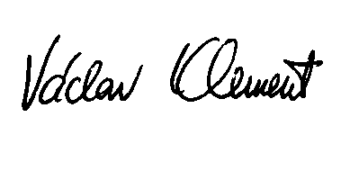
Fr Vaclav Klement

Missions Councillor

attachment: Salesian Mission Day (booklet for 2011, p.10-11)

